NASA RASC LUNAR HABITAT

Final Report

Jelani Peay
Salar Golshan
Aidan O’Brien
Ryan Navarette
Keerthi Nagaruri

2021



Project Sponsor: NASA RASC
Faculty Advisor: David Willy

DISCLAIMER
This report was prepared by students as part of a university course requirement. While considerable effort has been put into the project, it is not the work of licensed engineers and has not undergone the extensive verification that is common in the profession. The information, data, conclusions, and content of this report should not be relied on or utilized without thorough, independent testing and verification. University faculty members may have been associated with this project as advisors, sponsors, or course instructors, but as such they are not responsible for the accuracy of results or conclusions.

EXECUTIVE SUMMARY
Designing, engineering, and constructing a lunar habitat unit(s) requires the most sophisticated, intricate planning. Several factors would go into designing a fully functional livable structure. The surface environment, lunar soil variations, solar radiation, livable volume, maintaining a constant supply of necessary resources (air, water, and food), waste management are some of the many components that must be factored into the design criterion. Material and structural choices alone are heavily dependent on the factors mentioned above. As a result, the scope of the project will be limited to designing a structure that complies with the customer requirements. Heavy analysis will go into designing, engineering, and testing a structure for assembly on the lunar surface. The necessary systems and resources will be researched on and ideal subsystems will be chosen based on projected performance on the lunar surface. A focus on astronaut safety was prioritized over all other design requirements, and most of the testing and calculations are done on subsystems directly related to astronaut safety. Specifications for the design are based on standard codes and regulations from NASA, ASME, ASNI, and ASTM to ensure that all of the subsystems are ready to be implemented. The final design included a lightweight bone-structure, pressure wall, Whipple shield, multi-layer insulation (MLI), internal life support systems, and air lock. Extensive testing and calculations were done on these subsystems to optimize the full system. The final design went through many iterations to better meet the proposed engineering requirements. Critical failures and risk analysis were considered for the subsystems the team thought would fail first, and improvements were proposed to meet a higher factor of safety. The team was able to meet all of the engineering requirements related to safety but fell short when it came to the mass limit and the budget. Future improvements could be made to better meet these safety requirements which is discussed in future work.

ACKNOWLEDGEMENTS
There are numerous faculties who have supported the Lunar Habitat Capstone Design group throughout the past year. Professor David Willy has been nothing short of truly supportive throughout the project as he has guided the group through multiple disheartening moments and stepping in as the faculty advisor once we lost our original one. Professor Perry Wood has been very supportive when it came to using the machine shop when creating the physical prototype. Multiple family members and friends assisted the team with prototyping, 3D printing, rolling sheet metal, etc. A very special thank you to the City of Flagstaff for miraculously stepping in and funding this capstone project in the last few months of the timeline.

TABLE OF CONTENTS

DISCLAIMER 1
EXECUTIVE SUMMARY 2
ACKNOWLEDGEMENTS 3
TABLE OF CONTENTS 4
1 BACKGROUND - -
1.1 Introduction ..- -
1.2 Project Description - -
2 REQUIREMENTS - 2 -
2.1 Customer Requirements (CRs) - 2 -
2.2 Engineering Requirements (ERs) - 3 -
2.3 Functional Decomposition - 4 -
2 - 4 -
2.3.1 Black Box Model (Update Black Box) - 4 -
2.3.2 Functional Model/Work-Process Diagram/Hierarchical Task Analysis - 4 -
2.4 House of Quality (HoQ) - -
2.5 Standards, Codes, and Regulations 7
3 DESIGN SPACE RESEARCH 8
3.1 Literature Review 8
3.1.1 Aidan 8
3.1.2 Jelani 8
3.1.3 Keith 8
3.1.4 Ryan 9
3.1.5 Salar 9
3.2 Benchmarking
3.2.1 System Level Benchmarking 10
3.2.1.1 Lunar Habitats: A Brief overview of issues and concepts 10
3.2.1.2 A Parametric Comparison of Microgravity and Macro-gravity Habitat Design Elements 10
3.2.1.3 Human Factors for Small Net Habitable Volume 11
3.2.1.4 SHEE: Self-Deployable Habitat for Extreme Environments 12
3.2.2 Protecting the Space Station from Meteoroids and Orbital Debris & Astro materials Research & Exploration Science Hypervelocity Impact Technology 12
3.2.2.1 Subsystem #1: Shielding Protection (i.e Micrometiorites & Space Debris) 13
3.2.2.1.1 Existing Design #1: Whipple Shield 13
3.2.2.1.2 Existing Design #2: Stuffed Whipple Shield 14
3.2.2.1.3 Existing Design #3: Multi-Shock Whipple Shield 14
3.2.2.2 Subsystem #2: Radiation Protection
3.2.2.2.1 Existing Design #1: Polyethylene Plastic (RFXI)
3.2.2.2.2 Existing Design #2: Regolith (Lunar Surface Dust)
3.2.2.2.3 Existing Design #3: Water Wall 16
3.2.2.3 Subsystem #3: Temperature Regulation
3.2.2.3.1 Existing Design #1: Passive Thermal Control System (P.T.C.S) Multi-Layer Insulation
3.2.2.3.2 Existing Design #2: Active Thermal Control System (A.T.C.S) Heat Collection
3.2.2.3.3 Existing Design #3: Existing Design #3: Active Thermal Control System (A.T.C.S) Heat Rejection
4 CONCEPT GENERATION (Checked_Keith)
4.1.1 Full System Design #1: Buried Lunar Dome
4.1.2 Full System Design #2: Space Cube
4.1.3 Full System Design #3: Truss Structure using space grade one handed truss system
4.1.4 Full System Design #4: Coffee Mug Design
4.1.5 Full System Design #5: Space Shipping Containers
4.1.6 Full System Design #6: Modular Spider
4.1.7 Full System Design #7: Babylon 6
4.1.8 Full System Design #8: Space Valkyria
4.1.9 Full System Design #9: Stack-able Space Cube
4.1.10 Full System Design #10: Space Cylinder
4.2 Subsystem Concepts Error! Bookmark not defined.
4.2.1 Subsystem #1: Power Generation and Storage
4.2.1.1 Design #1: Small Nuclear Generation: NuScale Power Module
4.2.1.2 Design #2: Solar Panels
4.2.1.3 Design #3: Hydrogen Fuel Cell
4.2.2 Subsystem #2: Insulation Material
4.2.2.1 Design #1: Lunar Regolith
4.2.2.2 Design #2: Multilayer Insulation (MLI)- Mylar
4.2.2.3 Design #3: Multilayer Insulation (MLI)- Kapton
4.2.3 Subsystem #3: Environmental Control
4.2.3.1 Design #1: ISS – Water Recovery System (WRS)
4.2.3.2 Design #2: ISS- Oxygen Generation System (OGS)
4.2.3.3 Design #3: Spacecraft Atmospheric Monitor (SAM)
4.2.4 Subsystem #4: Shielding
4.2.4.1 Design #1: Pressure Wall
4.2.4.2 Design #2: Whipple Shield
4.2.4.3 Design #3: Glass
5 DESIGN SELECTED – First Semester
5.1 Technical Selection Criteria
5.2 Rationale for Design Selection
6 IMPLEMENTATION – Second Semester
6.1 Design Changes in Second Semester
6.1.1 Design Iteration 1: Bone Structure
6.1.2 Design Iteration 2: Whipple Shield
6.1.3 Design Iteration 3: Pressure Wall
6.1.4 Design Iteration 4: Supports
6.1.5 Design Iteration 5: Floor
6.1.6 Design Iteration 6: Airlock
6.2 1/10th Scale Representative Prototype
6.2.1 Subsystem 1: Bone Structure and Pressure wall
6.2.2 Subsystem 2: MLI
6.2.3 Subsystem 3: Floor
6.2.4 Subsystem 4: Whipple Shield
6.2.5 Subsystem 5: Window
6.2.6 Subsystem 6: Air Lock
6.2.7 Subsystem 7: ECLSS
7 RISK ANALYSIS AND MITIGATION (Aidan and Jelani)
7.1 Potential Failures Identified First Semester
7.1.1.1 ECLSS
7.1.1.2 Whipple Shield
7.2 Potential Failures Identified This Semester
7.2.1 Whipple shield
7.2.2 Glass Window
7.2.3 Solar Panels
7.2.4 Heat Generation
7.3 Risk Mitigation
7.3.1 Whipple Shield
7.3.2 Glass Window
7.3.3 Solar Panel
7.3.4 Heat Rejection
8 ER Proofs
8.1 ER Proof #1 – Budget
8.2 ER Proof #2 – Number of Livable Days
8.3 ER Proof #3 – Radiation Reduction
8.4 ER Proof #4 – Heat Rejection
8.5 ER Proof #5 – Livable Space
8.6 ER Proof #6 – Mass Requirement
8.7 ER Proof #7 – Whipple Shield Energy Reduction
8.8 ER Proof #8 – Whipple Shield Energy Reduction
8.9 ER Proof #9 – Internal Air Pressure
9 LOOKING FORWARD
9.1 Future Testing Procedures
9.1.1 Testing Procedure 1: Bone Structure Weld Quality
9.1.1.1 Testing Procedure 1: Objective
9.1.1.2 Testing Procedure 1: Resources Required
9.1.1.3 Testing Procedure and Schedule
9.1.2 Testing Procedure 2: Whipple Shield Physical Impact Testing
9.1.2.1 Testing Procedure 2: Objective
9.1.2.2 Testing Procedure 2: Resources Required
9.1.2.3 Testing Procedure 2: Schedule
9.2 Future Work
9.2.1 Weight Reduction
9.2.2 Manufacturing Plan
9.2.3 Power System
10 CONCLUSIONS
10.1 Reflection
10.2 Post-Mortem Analysis of Capstone
10.2.1 Contributors to Project Success
10.2.2 Opportunities/areas for improvement
11 REFERENCES
12 APPENDICES
12.1 Appendix A: FMEA (ECLSS & Whipple Shield)
12.1.1.1 ECLSS FMEA
12.1.1.2 Whipple Shield FMEA
12.2 Appendix B: Descriptive Title

BACKGROUND

Introduction
In response to Revolutionary Aerospace Systems Concepts- Academic Linkage (RASC-AL), this final report discusses the final design proposed to construct a durable, low-mass lunar habitat. As part of a new era of space exploration, NASA’s Artemis Missions will prepare humanity for the next giant leap, a manned mission Mars. The Artemis project’s main objective is to establish a lunar presence by the end of 2028. Since the Apollo Missions, it has been understood that space is a harsher environment for life than previously understood. A lunar presence would increase the opportunity for further science, establish lunar commerce, extract resources, and use the moon as a waystation to further exploration into space ensuring human survival.

Project Description
The following text contains the original project description provided by NASA:
DURABLE LOW-MASS LUNAR SURFACE HABITAT
After the initial Artemis mission lands the first woman and the next man on the Moon in 2024, the Artemis program will continue with longer and bolder missions on the lunar surface throughout the 2020s. A key enabling system for those future missions will be a habitat that can support crew on the lunar surface, as they continue the exploration of the Moon and prepare for future missions to Mars. To leverage developing commercial lander capabilities, NASA is interested in a low -mass habitat that can be used on the lunar surface.
For this theme, teams will design a durable, low-mass habitat that can support a crew of 2 for 30 days at the lunar south pole, with a dry mass limit of 6,000 kg. The habitat should be ready for first use in 2028, with an annual budget of no more than $1 billion per year from 2022-2028 (including delivery to the lunar surface). Teams should create a development timeline with a realistic technology portfolio that can credibly achieve that date. The habitat should be capable of re-use, as it will serve as the starting point for expanding to greater crew capabilities on the surface, and for preparation for Mars missions. Thus, teams should identify how their habitat can be used to support both of these goals.” - NASA RASC-AL

REQUIREMENTS
Every engineering project has a goal, and with every goal comes its associated customer and engineering requirements. Customer requirements were informed by the team’s faculty advisor and instructor. Weights were assigned to each customer requirement on a 1-10 scale, with astronaut safety taking main priority, followed by project feasibility. This would include budget and transport related requirements. The engineering requirements were generated to fill our customer requirements, and were all assigned measurable units, target values, and associated tolerances with each target value. Sections 2.1 and 2.2 list and describe the customer requirements and engineering requirements the team generated respectively.

Customer Requirements (CRs)
The customer requirements for the project were re-evaluated after a lot more thought had been put into the design of the habitat. Many customer requirements were changed slightly or removed entirely because of their irrelevance to the quality of the design. The “ease of assembly” and “Can be disassembled and reused on lunar surface” requirements was removed because most of the habitat is pre-assembled and only needs to be moved into place. The habitat is not designed to be disassembled by the astronauts for it to be reusable and is aiming for a more permanent style of shelter on the moon. The “Can fit on a rocket” requirement was simply changed to “Transportable for simplicity. The “payload limits of existing systems” requirement was removed because it falls under the “Transportable” requirement. The shield radiation requirement was removed from customer requirements because it falls under the “safe” requirement. The customer requirements that applied to the project, and associated weights are listed and expanded upon below:
1. Be Able to Support Own Weight (Weight Assigned = 8) – The structure would need to support its own weight to house and protect astronauts. The team weighed this customer requirement highly because it directly effects astronaut safety.
2. Supports 2 Crew Members (Weight Assigned = 6) – This customer requirement was formed using the project description given by NASA. The team weighted this one somewhat neutrally because it did not directly affect the safety of the astronauts, or the feasibility of the project. Although it was still important, because the habitat could not only support one astronaut as this would severely affect their mental health.
3. Safety (Weight Assigned = 10) – This is a more general customer requirement which encompasses all safety related requirements. It was created to understand the importance values of safety related engineering requirements for the team to have astronaut safety as the priority. As stated above, this customer requirement was rated a 10 for the sole purpose of ensuring that we have safety related requirements as top priority.
4. Comfortable (Weight Assigned = 4) – A comfortability requirement is an excellent way to ensure that the astronauts living in the habitat for one month are not cramped or otherwise uncomfortable. Although it is a nice requirement to have, it is not rated highly because it does not affect astronaut safety, or project feasibility.
5. Under Budget (Weight Assigned = 9) – This customer requirement simply states that the project must come in under the specified budged given to the group. This was rated highly because it would make the project unfeasible if over budget.
6. Ready for Use in Specified Time (Weight Assigned = 6) – This customer requirement was also created using the project description. It was rated somewhat neutrally because it had some effect on project feasibility, however it did not affect astronaut safety at all.
7. Transportable (Weight Assigned = 9) – The structure would have to be able to fit on existing rocket designs to be transported to the moon. The team weighed this customer requirement highly.

Engineering Requirements (ERs)
The engineering requirements were also updated to match the new customer requirements. The radiation levels and inside air temperature requirements were changed to radiation reduction and heat rejection because these requirements were easier to quantify. The assembly time requirement was removed because the habitat is mostly pre-assembled, so the little assembly time to get it operational would be negligible. The air loss requirement was removed because the amount of air-loss across the 30 days would also be negligible. Due to the condensing of the customer requirements, the “reusable” engineering requirement quantified in # of assemblies no longer made sense, since the habitat is designed to be a permanent structure. As a result, this requirement was also removed. The engineering requirements with associated units and target values with associated tolerances are listed in order of relative technical importance (RTI) below:
1. Budget ($ per Year, 13.7% RTI) – This requirement was also created with the help of the team’s faculty advisor to push the team towards innovative solutions. The reasoning behind this is NASA often considers innovative ideas even if they are not completely feasible because they could be made to work in the future. For this reason, the team rated this requirement neutrally, because it had no effect on astronaut safety, but creating an innovative design could help the feasibility of the project.
2. Livable Space (m3 , 13.5% RTI) – The amount of livable space had a target value of 50 m3 and a tolerance of 5 m3 . The team could not benchmark these values on the ISS because it is much larger scale than the lunar habitat, so the target value was based on values approximated by engineering toolbox for what amount of space people can live comfortably in. This value also accounts for supplies, equipment, and samples brought in by astronauts. The tolerance value allows the team some room for change in the overall design. This engineering requirement was rated high because the mental health and comfortability of the astronauts is important to the success of the mission.
3. Dry Mass Limit (kg, 13.5% RTI) – The habitat had a dry mass limit requirement of 6000kg with a tolerance of 100kg. This engineering requirement was essential to meet the transportable customer requirement.
4. Inside Air Pressure (KPa, 13.0% RTI) – The inside air pressure requirement had a target value of 101 kPa with a tolerance of 0.25 kPa. These values are based on the pressures that are used in the international space station, which is atmospheric pressure at sea level. This engineering requirement is necessary for the safety and comfortability of the astronauts.
5. Heat Rejection (kW, 12.6% RTI) – The life support systems aboard the lunar habitat module produce an excess amount of heat to keep the astronauts alive. The heat rejection system had an approximate target value of 30kW with a tolerance of 2kW based off the approximate amount of heat that would be outputted by the life support systems. This engineering requirement is necessary to keep the astronauts from overheating inside the habitat, which would affect their comfortability and safety.
6. Radiation Reduction (%, 11.4% RTI) – The habitat is required to have a shield to protect the astronauts from the unfiltered solar radiation present on the lunar surface. This requirement is crucial for the well-being of the astronauts aboard because exposure to high levels of solar radiation for extended periods of time leads to severe health issues and death. This engineering requirement had a target value of 60% with a tolerance of 5%.
7. Number of Livable Days (Days, 11.3% RTI) – The number of livable days had a target value of 30 days as provided by the project description and had a tolerance of 1 day. This value was decided on with the limited number of resources that the astronauts could bring to the moon. More than 1 day without sustenance could cause the astronauts to get weak, and not be able to complete the mission.
8. Whipple Shield Impact Absorption (J, 11.1% RTI) – The Whipple shields are crucial to preventing punctures in the event of a micrometeorite impact. Because of this this requirement is imperative to the safety of the astronauts. The target value was 259 J with a tolerance of 10 J.

Functional Decomposition
A black box and functional model were created to get a better understanding of how the lunar habitat system works. The black box model gives the team an overall understanding of the inputs and outputs, and the functional model shows a more detailed representation of how the different inputs react with one another. Minor changes have been made to the functional model to improve its readability, as well as including the micrometeorite protection subsystem for better overall representation of the system.

Black Box Model (Update Black Box)
The black box model is a diagram which analyzes the inputs and outputs of a system. This is a useful tool in the concept generation process as it illuminates the different kinds of flows to design around. The bold, heavyweight line represents the material flows, which include anything physical that takes up space entering the system. The term “solids” is used to describe any equipment, supplies, samples, and other physical materials that the astronauts will be bringing into the system with them. The black lightweight line is used to represent energy which flows into and out of the system. Energy can take many forms, however in this case only radiant energy from the sun, and electricity from external sources are relevant. The dashed line represents signal flows. Signals are waves which carry information, in this case radio waves are used to communicate with NASA. Figure 1below displays the teams Black Box Model.
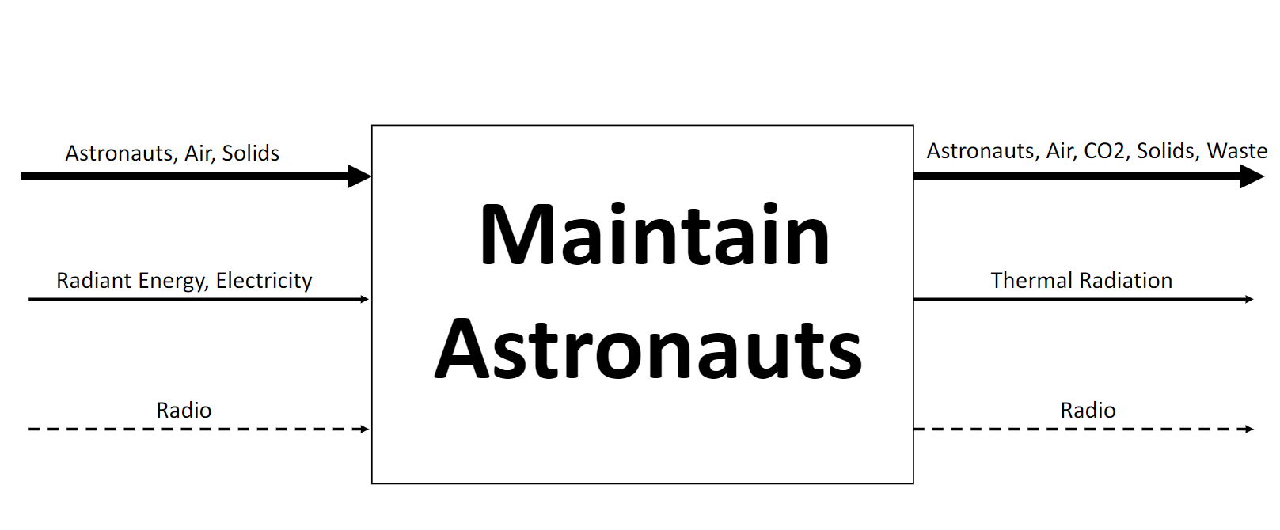
Figure 1: Black Box Model

Functional Model/Work-Process Diagram/Hierarchical Task Analysis
The functional model is a more detailed breakdown of the flows into and out of the system. Notice how the same input and output flows from the Black Box Model are present in this model as well. Each subsystem starts with its own import function, where the material, energy, or signal flow is imported into the system. The overall system is broken down into 5 subsystems: radiation, air and temperature regulation, astronauts and solids, radio signals and finally power. The primary function for this system is to “maintain” or preserve astronauts. Inputs of air, conditioned air, astronauts, solids, and an auditory signal for communication are required to sustain the life of the astronauts. This model was useful for get a deeper understanding of what specific subsystems accomplish. It gave the team a good idea of what subsystems to benchmark, as well as helped the team consider how these subsystems would affect the overall design. This was useful in the concept generation process. The functional model also helps the team get an overall visual understanding of everything entering and leaving the system. The functional model was updated to include urine processing as part of the ECLSS subsystem. The radiation part of the functional model was also updated to be more accurate, showing radiation being absorbed and reflected now. Line breaking was also done to make the functional model read better. The micrometeorite protection subsystem was included to better represent the full system. Figure 2 below shows the teams finished functional model.

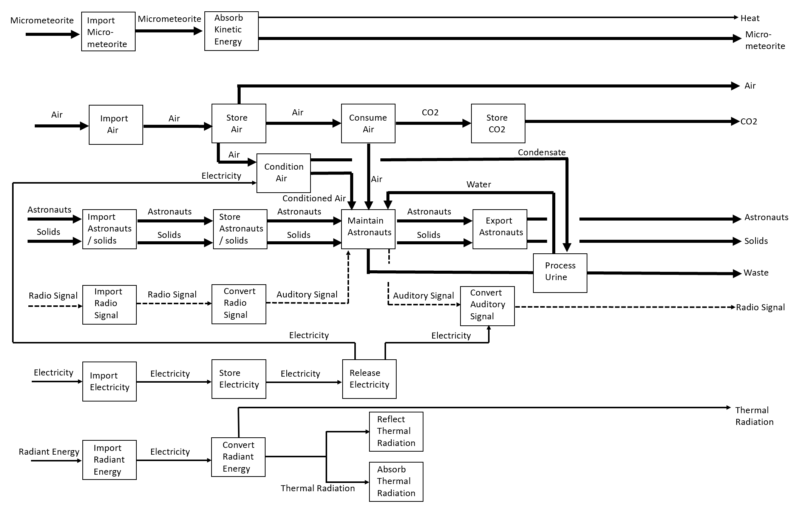
Figure 2: Functional Model

House of Quality (HoQ)
A House of Quality (QFD) was used to rate and evaluate the team’s customer requirements and engineering requirements. This helped our team select the most important design aspects for the lunar habitat. Testing procedures, target values, and tolerances are described for each of the engineering requirements Table 1 below shows the teams House of Quality.

House of Quality (HoQ)
Customer Requirement | Weight | Number of Livable Days (Days) | Budget ($ per year) | Liveable Space (m^3) | Dry Mass Limit (kg) | Radiation Reduction (%) | Whipple Shield Energy Absorption (J) | Heat Rejection (kW) | Inside Air Pressure (kPA)
1. Be able to support own weight | 8 | 6 | 4 | 3 | 8 | 2 | 2 | 2 | 8
2. Supports 2 Crew Members | 6 | 9 | 5 | 9 | 4 | 6 | 5 | 10 | 8
3. Safe | 10 | 7 | 5 | 4 | 2 | 10 | 10 | 7 | 9
4. Comfortable | 4 | 3 | 5 | 10 | 2 | 8 | 4 | 10 | 7
5. Under Budget | 9 | 3 | 10 | 5 | 8 | 4 | 5 | 4 | 2
6. Ready for use in specified time | 6 | 1 | 4 | 5 | 6 | 3 | 4 | 3 | 6
7. Transportable | 9 | 5 | 8 | 9 | 10 | 3 | 3 | 6 | 2
Absolute Technical Importance (ATI) |  | 262 | 318 | 314 | 314 | 265 | 258 | 294 | 302
Relative Technical Importance (RTI) |  | 11.3% | 13.7% | 13.5% | 13.% | 11.4% | 11.1% | 12.6% | 13.0%
Target ER values |  | 30 | 1 Billion | 50 | 6000 | 60 | 259 | 30 | 101.325
Tolerances of Ers | +/- | 1 | 1E+06 | 5 | 100 | 5 | 10 | 2 | 15
Testing Procedures |  | ECLSS ANALYSIS | BUDGET ANALYSIS | SOLID  WORKS | SOLID  WORKS | RADI-ATION CALC | SOLID  WORKS  SIMUL-  ATION | HEAT  EXCHANGER  CALCULATION | SOLIDWORKS  SIMULATION

Table 1: House of Quality (QFD)

Standards, Codes, and Regulations
Table 2: Standards of Practice as Applied to this Project
Standard Number or Code | Title of Standard | How it applies to Project
ASNI/AAMI HE 74:2001 | Human Factors Design Process for Medical Devices | Helps in the design of how the device with interface with the user in a safe manner.
NASA-STD-3001 VOL 1 | NASA Space Flight Human-System Standard Volume 1, Revision A: Crew Health | Goes into depth on the importance of maintaining crew health. Useful for design of ECLSS systems.
NASA-STD-3001 VOL 2 | NASA Space Flight Human System Standard Volume 2: Human Factors, Habitability, and Environmental Health | Discusses effects of environmental conditions on crew health. Useful for design of ECLSS systems.
NASA-STD-5001 | Structural Design and Test Factors of Safety for Spaceflight Hardware | Gives standard factors of safety for structural design for space. Useful for structural analysis of habitat.
NASA-STD-6016 | Standard Materials and Processes Requirements for Spacecraft | Discusses materials and process that materials need to undergo to be ready for use in space. Useful for specifying a budget and Bill of Materials
NASA-STD-7002 | Payload Test Requirements | Useful for figuring out how to test if the habitat meets payload requirements.
ASME Y14.5M-2004 | ASME National Standard Engineering Drawing and Related Documentation Practices | This Standard establishes uniform practices for stating and interpreting dimensioning, tolerancing, and related requirements for use on engineering drawings and in related document.
ASTM F593-17 | Standard Specification for Stainless Steel Bolts, Hex Cap Screws, and Studs | Aids in the design of our M-24 steel hex head bolts so we can ensure the structural integrity of our micrometeorite shield.
ASTM D8101/D8101M-18 | Standard Test Method for Measuring the Penetration Resistance of Composite Materials to Impact by a Blunt Projectile | This engineering standard gives our team insight into how we can test the impact resistance of our own composite materials (i.e. Kevlar & Nextel)
ASTM B646-19 | Standard Practice for Fracture Toughness Testing of Aluminum Alloys | Helps our team the limitations of our aluminum alloy since it will be under a lot of fatigue due to the frequent temperature variation that occurs on the lunar surface

DESIGN SPACE RESEARCH

Literature Review
Over the course of the first semester of our senior project our team conducted a literature review to gather as much knowledge and literary resources on how to construct a safe habitat. Our research consisted of understanding the topography and terrain of the lunar surface’s south pole, gathering lunar habitat concepts to benchmark off of, understanding how to design a structurally sound habitat in space, material selection, and how being in space can change to human body. Each of these resources aided in our goal of designing a lunar habitat that could successfully house two individuals for a total of 30 consecutive days.

Aidan
Lunar South Pole Map [1] – Thermal map of the lunar south pole region. Shows temperature variations in craters and describes what temperatures to expect in the region. This source can help us select materials based on temperature extremes.

eBook on Space Radiation by NASA [2] – Describes effects of space radiation on humans and other living things and gives us tools to defend against radiation. Radiation is a critical design condition for this project.

Lunar Sourcebook: A User’s Guide to the Moon [3] – This book has a plethora of information on the surface conditions of the moon. From temperature variations to the deadly lunar dust, this book is an excellent source of information to help design a habitat on the moon.

Jelani
Lunar Habitat (website) [4] – The Lunar Mark 1 is a concept that utilizes origami and biomimicry to create an easily transportable and self-sustaining lunar habitat. This design will aid our team by giving us insight into ways we could efficiently reduce the volume of our own.

"Double Shell" Habitat (Journal) [5] – The double shell habitat uses a cylindrical aluminum exterior as well as foam-glass and regolith for insulation and radiation protection respectively. Our team could use a similar idea for our own design to ensure the safety of the astronauts.

ICON 3-D Printing Lunar Surface Habitat [6] - Conceptual 3-D printed lunar habitat made entirely out of moon dust. This idea would help our team not only save money but reduce the exposure of radiation for our astronauts because the printer would build the habitat.

Keith
Airtight Structure design for manned vehicles [7] - Space Structure designs are typically designed using elastic deformation and safety factor methods. This paper discuses an alternative method of analysis called shake down analysis where the simulations are first generated and then prototypes are tested in the lab.

Automatic Pressure Control and Load Simulation [8]- Space structures based on inflatable flexible inflatable membranes that provide the rigidity necessary as well as load disbursement. This paper discusses an automated pressure control system along with load simulation techniques.

Space Structures and Improvements [9]- This paper focuses on improvements in manned space vehicles over the years. Space travel is very complicated although a lot has been improved on, concepts such as reentry into earth’s atmosphere is not a guaranteed. This paper discusses in depth on structure design of various shapes and materials for space application.

Ryan
The Space Materials Database (SPACEMATDB) [10] – This source provides a detailed list of 418 space ready materials and includes physical, environmental, mechanical and thermal properties reinvent to space applications.
Materials and Manufacturing PDF [11] – NASA describes the challenges of the design of the Space Shuttle systems, the innovations in materials solutions and overcoming manufacturing limitations.
Introduction into aerospace materials E-Book [12]– introduces the science and engineering of materials used in aerospace applications, and examines the structural materials used in airframe and propulsion systems.

Salar
Lunar Habitats: A Brief overview of issues and concepts [13] – This source dives into the fine detailed specifics of the moon and all the facts humans would need to know to survive there. It explains how the diurnal cycle of the moon is 29.53 Earth days with the temperature ranging from -128 to 136 degrees Fahrenheit.

Nasa Space Flight Human-System Standard V2 [14] - Missions of longer than 2 weeks must contain physiological inert diluent gas. Temperatures should range from 18-27 degrees Celsius. Potable water bacterial max count should be 50 CFU/ml.

Nasa Space Flight Human-System Standard V1 [15] - In flight nutrient intake-90% of calculated nutrient intake. In-flight aerobic capacity shall be maintained at no less than 32.9 ml•min-1•kg-1.

Benchmarking
This student aimed to focus their research on human factor requirements that would affect the design of the habitat. The research of habitat designs also proclaimed on this student throughout the initial weeks of the semester. The focus was to discover specific requirements and values that would designate parameters throughout the sustainable lunar habitat design for the scientists and astronauts.

System Level Benchmarking

Material Selection
The focus of this team members research materials, material selection manufacturing methods and design standards to understand the scope of the project and create a design that meets the constraints of the project. The resources found below highlight the top five sources the student found most effective in understanding available materials, manufacturing processes, and design standards:

- The Space Materials Database (SPACEMATDB)

This database provides a detailed list of 418 space ready materials and includes physical, environmental, mechanical, and thermal properties as they pertain to space applications. The data base was compiled by Dr. Antonius de Rooij, former principal metallurgist in the Materials and Process Section at the European Space Agency and has over 30 years of experience with aerospace capable materials. The database serves as a basis for material selection, however, further research on individual materials of interest should be done.

- Materials and Manufacturing PDF (Portable Document Format)

In this chapter, the author describes the challenges NASA faced with the design of the Space Shuttle systems, the innovations in materials solutions and overcoming manufacturing limitations. This document provides valuable insight into innovative problem solving and the manufacturing of the space shuttle and the hurtless engineers might encounter, with insight into a solution. An example of the testing required for designs is shown in Figure 3, in which the tile attachment for the space shuttle via use of a nondestructive test known as acoustic emission monitoring.

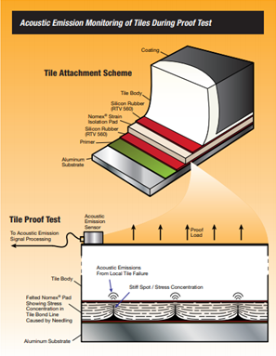
Figure 3. Acoustic Emission Monitoring of Tiles During Proof Test [Ryan 2]

- Introduction into Aerospace Materials
This book introduces the science and engineering of materials used in aerospace applications, and examines the structural materials used in airframe and propulsion systems. There is significant emphasis placed on the structural materials used within aerospace applications due to the influences on cost, performance, reliability, and safety that the materials have on these applications.

- Fundamentals of Modern Manufacturing: Materials, Processes and Systems
This book describes modern manufacturing processes of metals, ceramics, polymers, and composite materials. The manufacturing processes range from traditional processes that have been refined throughout the centuries and the implementation of electronics into the manufacturing processes. There is also an extensive section on Geometric Dimensioning and Tolerancing (GD&T); that covers the basics one would need to learn to properly convey design intent and properly understand manufacturing limitations. Table X1 shows typical geometric controls found in the geometric tolerance block. Figure 4 is the general set up of a geometric tolerance block. Table X2 shows the typical tolerance of common manufacturing processes covered within the book.

Table X1. Geometric Controls
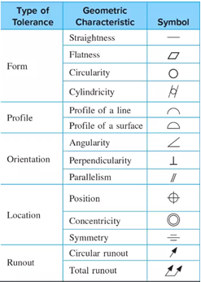

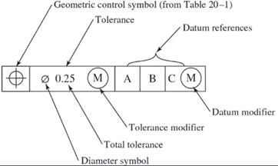
Figure 4. Feature Control Frame

Table X2. Typical Tolerance limits for various manufacturing processes
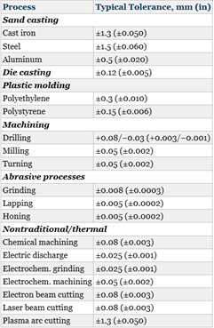

- Dimensioning and Tolerancing: ASME Y14.5-2004

The ASME Y14.5 2004 (or 2009) is a drawing standard created by the American Society of Mechanical Engineers (ASME) to ensure quality, reliability, and safety. This standard relies on the user to have a basic understanding of GD&T and proper designing methods. The 2004 version was created to properly convey design intent and provide a universal drawing standard that engineers from different companies and manufacturing plants may understand.

Lunar Habitats: A Brief overview of issues and concepts
The cylindrical module base proposal provides a great leeway for expansion. In order to land the modules on the moon and maneuver the base to the appropriate final destination on the lunar surface, a Teleoperated Rocket Crane would be incorporated. This crane would be assembled within the lunar orbit and then descent to the lunar surface. A configure of the design is illustrated below in figure 3 [16].
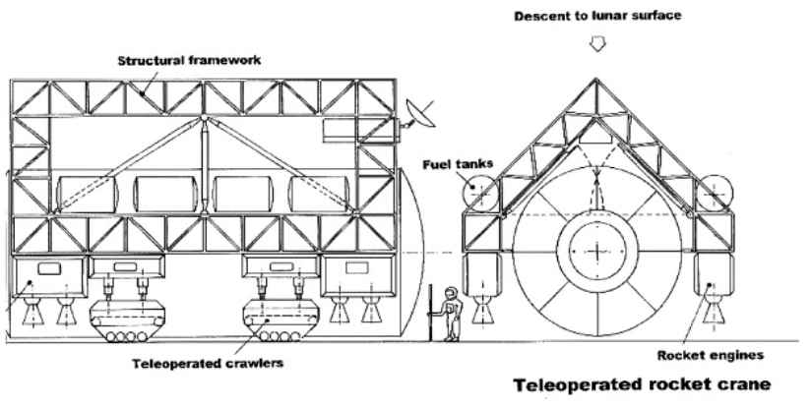
Figure 3: Teleported Rocket crane

This design will have an outer shell made from aluminum sheets incorporated through a double shell structure to intensify the strength from micrometeorites, radiation and temperature differentials. This design will also incorporate lunar regolith for shielding. The inner height of each module will be approximately 2.8 meters tall and 4 meters in diameter.

A Parametric Comparison of Microgravity and Macro-gravity Habitat Design Elements
Various equations are presented to define the minimum amount of space an astronaut would require depending on the duration and amount of crew members. Based on provided equations considering gravitational pulls across the planets, the text suggests that Mars climbing velocity is sufficient to cause the foot used to step upwards to float upwards off the departing step almost to the next step. When observed in microgravity, humans adopt a neutral body posture which represents the lowest muscle energy equilibrium state. A figure of the thorough study of the human body posture is shown below in figure 4 [17]
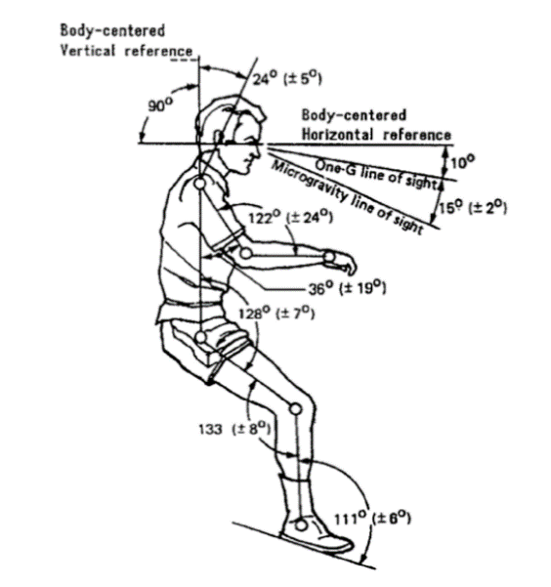
Figure 4: Human Body Posture in Low Gravity

Human Factors for Small Net Habitable Volume
The case for close quarters space habitat analog. – This is a research paper that was the result of collaboration between the University of Houston and the Aeronautical University, and it discusses how habitat design affects crew performance and behavioral health. The isolation, confinement, lack of privacy, necessary volume of air, water and ideal workspace are some key components taken into consideration to examine the net habitable volume (NHV) necessary for crew well-being on space missions. Below is the table outlined in the article that defines major psychological stressors. Table 3 below shows the psychological stressors experienced for long duration missions [43].
Table 3: Psychological Stressors Experienced for long-duration ICE Habitations related to Habitable volume [43]
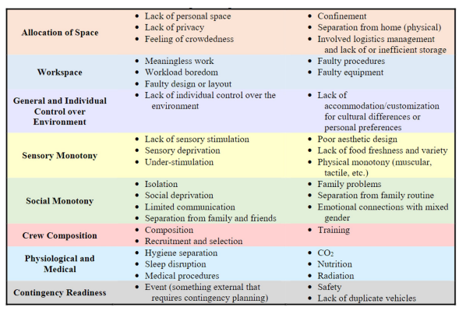

Using the table above and the harsh space conditions, the report investigates the net habitable volumes for several vehicles designed for various lengths and crew sizes. The report also outlines potential emergency situations such as fires, gas leaks, depressurizations, and solar particle events. The report then concludes that testing small habitats such as the self-deployable habitat for extreme environments could offer solutions to emergency situations. The key figure obtained is the NHV for individuals is 25m³ per person.

SHEE: Self-Deployable Habitat for Extreme Environments
This report discusses a potential foldable structure designed for extreme environments (including space). The design incorporated interior criteria such as areas designated for Food (storage, preparation, and consumption), Hygiene, Workspace, Personal Quarters, and air lock. The design considers the NASA NHV of 25m3 per person, as well as the current industry standards for manufacture and assembly. The figure below describes the foldable design. The figure below describes the inner layout and the necessary support system locations. The design offers key criteria for designing a habitat for a crew of 2 and how the necessary support systems would fit. Figure 5 below shows the deployed and folded configurations for the SHEE design [19].
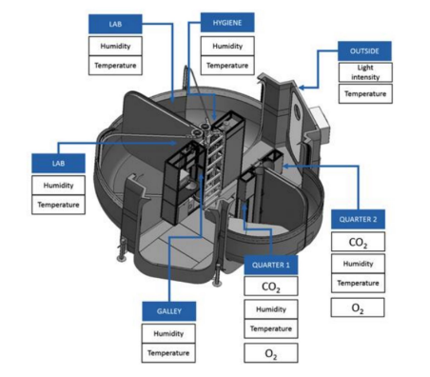
Figure 5: Deployed and Folded Configurations for the SHEE Design [42]

Protecting the Space Station from Meteoroids and Orbital Debris & Astro materials Research & Exploration Science Hypervelocity Impact Technology

Subsystem #1: Shielding Protection (i.e., Micrometeorites & Space Debris)
This subsystem is an important part of our functional model as our team has adapted a Whipple Shield which will account for micrometeorite impacts. The team needs to address the various existing designs for shielding so that we can ensure the safety of the astronauts for the length of the mission.

Existing Design #1: Whipple Shield
The Whipple Shield as shown in Figure 9 [20], is an intuitive design created for the purpose of protecting crew members within space modules from micrometeorites and space debris. It is comprised of up to four layers starting with aluminum on the outer layer. Aluminum is a lightweight metal that is durable enough to vaporize the high velocity objects that it would encounter. The two inner layers would be comprised of either Kevlar or Nextel due to of the material’s high tensile strength and low porosity. Lastly, the innermost layer is also comprised of aluminum as a fail-safe just in case the object did not fully vaporize on impact with the first layer. So, to summarize if an object is moving upwards at a velocity of about 15000 m/s and impacts the shield the first layer will vaporize it until it is nothing by microscopic dust. The second layer will then provide a way for the high kinetic energy of the now disintegrated object to be dispersed over a large area rendering it harmless. Finally, the inner most layer will act as a fails-safe just in case the object did not fully disintegrate on impact [21]. This existing design would be great to benchmark off because the lunar surface is bombarded by micrometeorites at the same speed, so it is useful knowing that there is a design that has been successfully tested to withstand that kind of force.
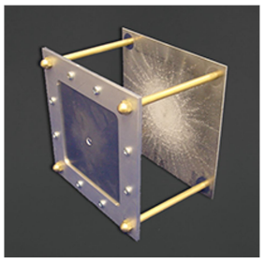
Figure 9: Whipple Shield

Existing Design #2: Stuffed Whipple Shield
The Stuffed Whipple Shield works in the same manner as the Whipple Shield except there are more layers between the plates of aluminum. The concept is a derivative of its predecessor and is currently being used on the ISS [21]. This design is better suited for objects moving faster than 15000 m/s because it has more layers of Nextel in between the aluminum. Nextel is a fantastic material for this kind of application because it has a strength of close to 3000 MPa. Since it has already been tested in a hazardous environment and proven successful, we can utilize the same idea to protect our astronauts from similar dangers.

Existing Design #3: Multi-Shock Whipple Shield
The Multi-Shock Whipple Shield is the same concept as its predecessor the Whipple Shield with the exception that is has multiple layers of Nextel between the aluminum. Once an object impacts the shield the Nextel layers continuously shock it until it is rendered harmless. To ensure that the layers continuously shock the object the layers are evenly spaced apart to not offset the process. Using Nextel as the material between the aluminum would be useful because the material is very lightweight weighing in at 9.6g/m . However, economically speaking Nextel is very expensive in fact it costs $1250/kg [22]. Which depending on how much the team would need could strain the materials and manufacturing portion of our budget so that is something that we need to be tabulated.

Subsystem #2: Radiation Protection
Radiation is something that the team needs to analyze and prepare protective measures for because unlike the Earth the Moon does not have a magnetic field to filter out the ionizing electromagnetic waves (i.e., X-Rays, Gamma Rays, and UV Rays). This will be a difficult task because there is not a lunar module to benchmark from, except for the ISS. The ISS, however, is partially protected by the Earth’s magnetic field so we might need to add more countermeasures in our own design to successfully accommodate the astronaut’s safety.

Existing Design #1: Polyethylene Plastic (RFXI)
RFX1 is a plastic material that is rich in both carbon and hydrogen and possesses the ability to protect astronauts from ionizing radiation. It is a derivative of Polyethylene which is rich in hydrogen and currently keeps the crew members of the ISS safe. This material is currently in the research and testing phase, but it may be beneficial for our team to consider this option as a solution. The reason being is according to NASA Human Research Program Engagement and Communications [23]; this material is 50% better at shielding against solar flares and 15% better at shielding against cosmic radiation than aluminum (which is sometimes used as a shield against radiation). Since RFX1 is comprised of hydrogen and carbon (which have a low molar mass) the chances of secondary particles dispersing after impact and harming our inhabitants decrease exponentially. As a rule of thumb, we will need to pay close attention to materials with a larger molar mass because the chance of secondary particles dispersing increases as the atomic radius increases. What also makes RFX1 an exceptional material is the fact that it can withstand up to 1x1012 micro-Sieverts (µSv) of radiation as shown in figure 10[24]. This will be an important characteristic since the most radiation that our design will encounter over the course of 30 days is 40320 (µSv) it is safe to say that we will be able to protect our astronauts from the adverse effects of radiation exposure [25].
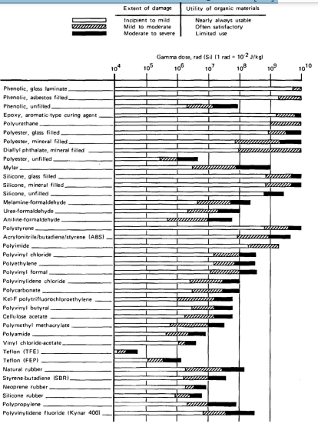
Figure 10: Gamma Radiation Dose Resistance for Various Materials

Existing Design #2: Regolith (Lunar Surface Dust)
Regolith is a fine granular substance that can be found on the surface of the moon and has a similar effectiveness in protecting against cosmic radiation. There are a couple of key differences as to why our team is considering using this material and one of those differences is its economic value. Since regolith is already on the moon all our team would need to do is 3-D print it into a usable substance instead of using a portion of our budget on another material. Another important difference is the fact that it is chemically made of light elements (Al2O3, CaO, Na2O, K2O) which have a lower chance of releasing more harmful secondary particles after impact with the shield [26]. Although regolith has not been used to protect human life as of right now, there have been experiments that have proven that it has the ability block a great deal of radiation. According to the NLSI Lunar Science Conference (who uses a regolith simulant) states that regolith with a thickness 15 cm and a density of 1.9 g/cm3 [27].

Existing Design #3: Water Wall
Water has the potential to serve as a barrier against radiation because since it has a low density and a low molar mass it can stop neutrons from harming our astronauts. However, materials with a low molar mass tend to give off gamma rays once they meet neutrons so our team will need to have a combination of materials that can block out neutrons and gamma rays [28]. Luckily a water-wall design has been tested aboard the ISS using a protective curtain that consisted of hygienic wipes and towels at a water thickness of about 6.3 g/cm2. To measure the difference between in radiation dose reduction the experiment was conducted on an unprotected package and a protected package. The results showed that the unprotected package had a radiation dosage of 821 µSv/day and the protected package had a radiation dosage of 575 µSv/day. This is a 37 ± 7% radiation reduction percentage which shows that water does have the capability to shield against radiation. However, our astronauts will be exposed to a greater deal of radiation because the moon does not have a magnetic field to block most radiation. So, we will need to design a barrier that can protect against neutrons as well as gamma rays. Figure 18 below shows a test for the water wall design [29]

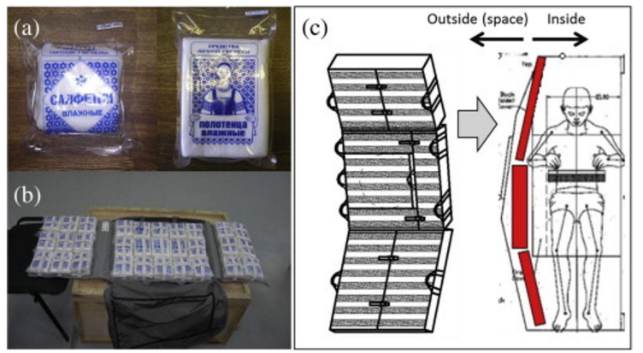
Figure 11: Water Wall Design Test

Subsystem #3: Temperature Regulation
Maintaining a comfortable temperature for our team not only increases the survivability rate of our astronauts for the entirety of 30 days but can also allow other life support systems to function properly. Our team has chosen three existing designs to benchmark off that we believe will help us design a successful subsystem.

Existing Design #1: Passive Thermal Control System (P.T.C.S) Multi-Layer Insulation
The ISS utilizes the PTCS to keep the cabinets and electronics at a comfortable and operational temperature. The multi-layer insulation material that assists in completing this arduous task is made up of Mylar and Kapton [30]. Both materials have a low thermal conductivity of 0.12 (W/m·K) and 5.24 · 10−3 (W/m·K) respectively [31] [32]. Since the rate of heat transfer is low because of the materials thermal properties the ISS can stay at a comfortable temperature of 24 °C [33]. This can be useful for our team because we can apply the same materials in a similar fashion for our habitat since the temperature ranges from 0 to 250 Kelvin.

Existing Design #2: Active Thermal Control System (A.T.C.S) Heat Collection
[Describe this subsystem-level existing design and explain how it relates to your requirements.]
The ATCS aids in keeping the temperature within the ISS at an optimal level by using three subsystems which is the Heat Collection, Heat Transportation, and Heat Rejection as shown in figure 12[34]. The Heat Collection utilizes several heat exchangers which are evenly distributed throughout the cabinets that the astronauts travel through. This is to ensure all sides of the ISS are the same temperature [35]. This will be extremely helpful 33 for our project because the temperature varies greatly throughout the surface of the south pole on the moon. So, this change in temperature is something we will need to account for.
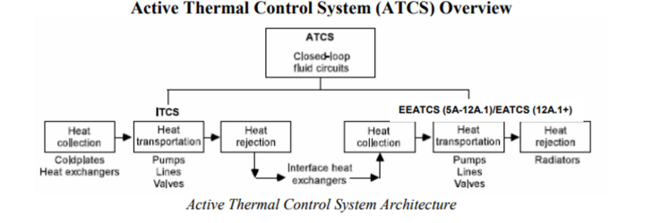
Figure 12: ATCS System Overview

Existing Design #3: Existing Design #3: Active Thermal Control System (A.T.C.S) Heat Rejection
[Describe this subsystem-level existing design and explain how it relates to your requirements.]
The Heat Rejection subsystem of the ATCS eliminates the heat that was not used from the ISS through two radiators as seen in figure 20 [35]. This task is accomplished by heating up water in closed loops of pipes during the heat of transportation phase. This steam is then transferred to other pipes that have ammonia within them. Lastly, the heated ammonia is then radiated outside the ISS and into space [35]. This efficiently helps the ISS stay at an optimal operating temperature which is imperative for the duration of our project. Depending on our budget we may be able to utilize a similar system, but it may be difficult to replicate this system because we have a dry mass limit of 6000 kg.

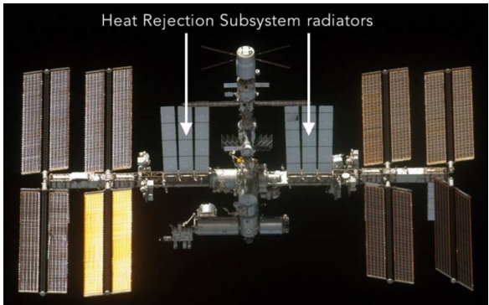
Figure 13: Heat Rejection Subsystem

CONCEPT GENERATION
[Provide the section from the final proposal in ME 476C regarding the concepts that you generated for this project. Mitigate any and all issues from the previous iteration of this section.]

Full System Design #1: Buried Lunar Dome
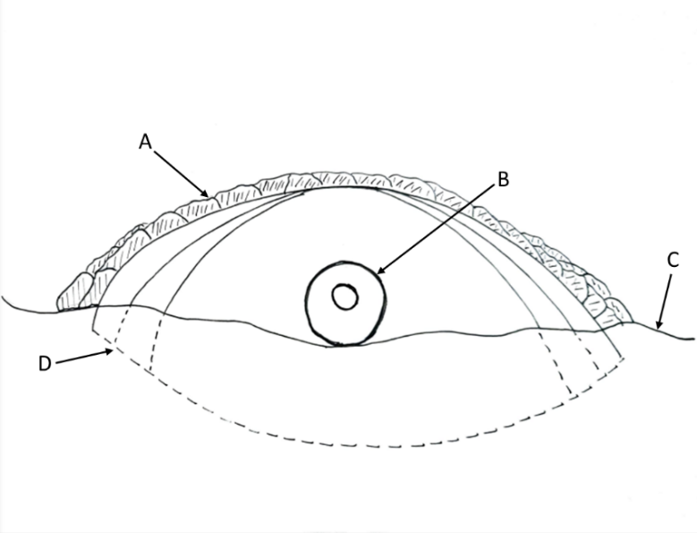
Figure 14: Buried Lunar Dome
Legend:
A – Regolith
B – Airlock
C – Lunar surface
D – Portion below ground
Description:
The is space structure is a dome that is buried into the surface of the lunar surface. Then large bags filled with lunar soil (Regolith) is then placed on the exterior of the dome in the direction of sunlight. There is an opening in the dome structure for entry/exit.
Advantages:
- Easier temperature control as the structure is partially submerged into the soil.
- The regolith will offset internal pressure.
- Protection from harmful radiation.
- Room for all life support systems.
Disadvantages:
- Expensive installation
- Digging into lunar surface could be tricky.
- Structure is to be built on the lunar surface using aluminum. This could be tricky.

Full System Design #2: Space Cube
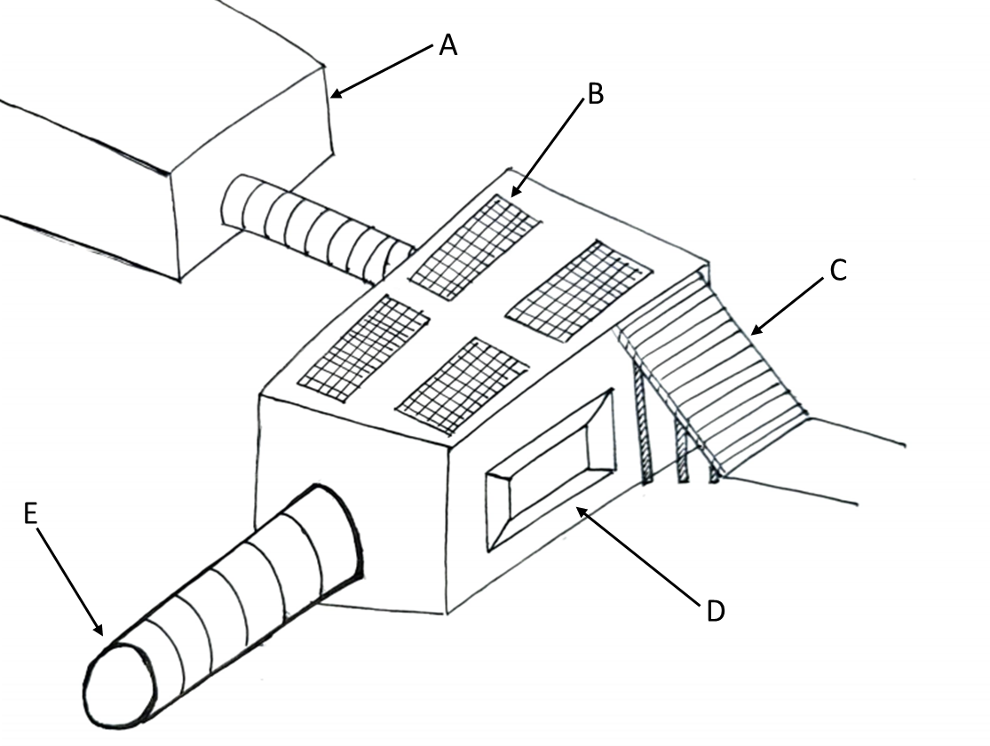
Figure 15: Space Cube
Legend:
A – Expandable structure
B – Solar panels
C – Stairs
D – Base attachment
E – Airlock
Description:
The space cube structure is assembled out of prefabricated walls that will be shipped to the moon. Number of man hours spent to assemble the structure is small and the cylindrical air lock is used to house additional air and to link additional structures together.
Advantages:
- Low cost
- Modular design allows for easier expansion.
- Meets minimum livable volume.
Disadvantages:
- Not reusable.
- Additional protection could be required to block radiation exposure.
- Extra strength is required to hold air pressure inside the structure.

Full System Design #3: Truss Structure using space grade one handed truss system

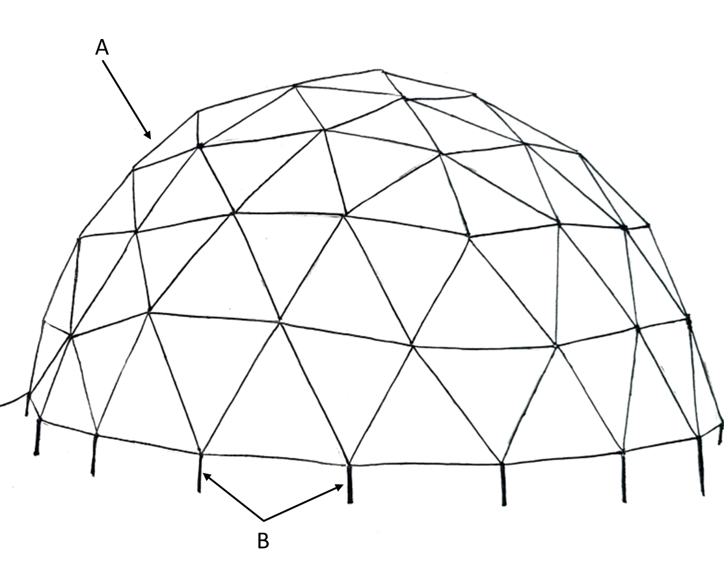
Figure 16: Truss Structure
Legend:
A – triangle dome structure with regolith imbedded in the walls.
B – Pegs/stokes that are sunk into the lunar surface.
Description:
This structure is made from trusses and beams that form a dome shape. It makes use of the one-handed truss locking mechanism developed for use on the international space station. Then the structure is anchored into the moon’s surface using spokes shown in the image. The structure is then covered with metal plates and regolith on the outer layer. The regolith adds structural integrity as it puts the structure under compressive force and offsets some of the internal pressure generated from air.
Advantages Structural integrity
- Lots of room
- Regolith counteracts internal pressure
- Structurally more stable
Disadvantages
- Routes for expansion might be difficult after being fully constructed.
- Could be heavy and requires additional time planning to assemble the structure.
- Structure assembly could be expensive.
- Not reusable

Full System Design #4: Coffee Mug Design
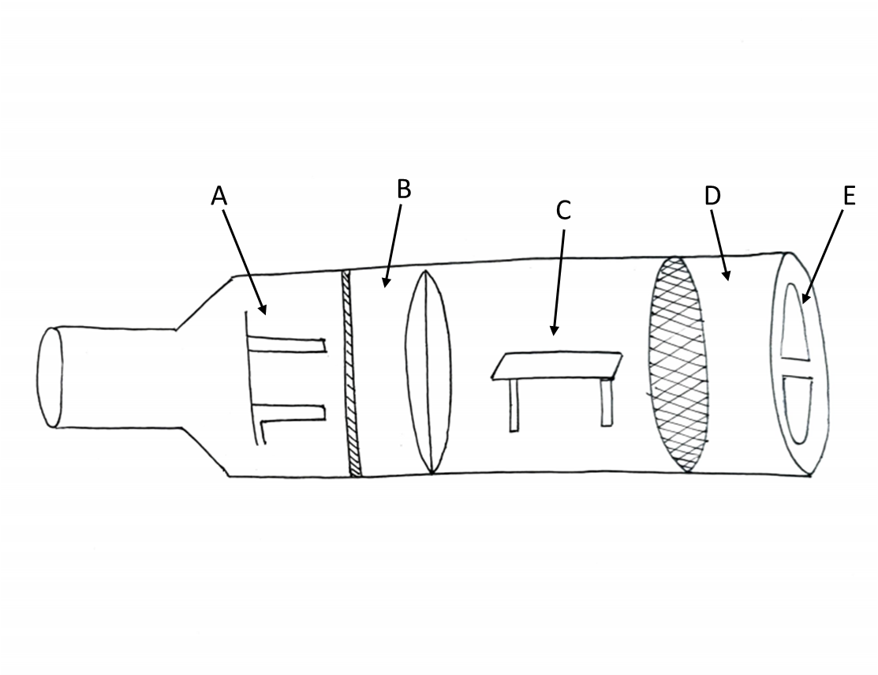
Figure 17: Bottle Habitat

Legend:
A – Bed
B – Shower
C – Workspace
D – Pressurized chamber
E – Door Hatch
Description:
The structure looks similar to a bottle where it is placed in the rocket fully assembled. Then the coffee mug is placed in the rocket and sent to the lunar surface and some material could be placed on top to reduce radiation exposure. The fully assembled design would mean cost savings overall.
Advantages:
- Costs less as the structure will be assembled on earth.
- Modular connections for future expansion.
- Assembled on earth would mean a more reliable testing.
- One shot trip.
- Limits radiation exposure.
Disadvantages
- Limited living space.
- Subsystems necessary might not fit within the structure.

Full System Design #5: Space Shipping Containers
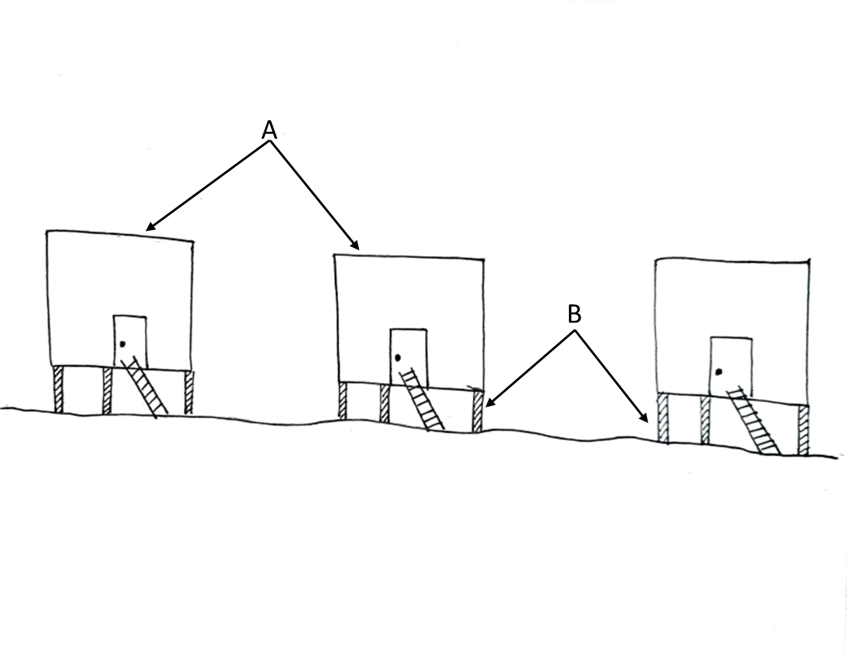
Figure 18: Space Shipping Containers
Legend:
A – Individual structures
B – Support legs
Description:
Shipping containers are very popular today. If we could repurpose them for space, it could mean huge cost savings in the long run. Although they might not be connected, the containers have a volume that is easy to design around. When placed near each other, the structures could form a small town.
Advantages:
- Simple design
- Low cost
- Easy expansion
- Low assembly time
- Reusable
Disadvantages:
- Fitting it into a rocket might be tough.
- Temperature control is tough.
- Levels of radiation exposure will be high.

Full System Design #6: Modular Spider
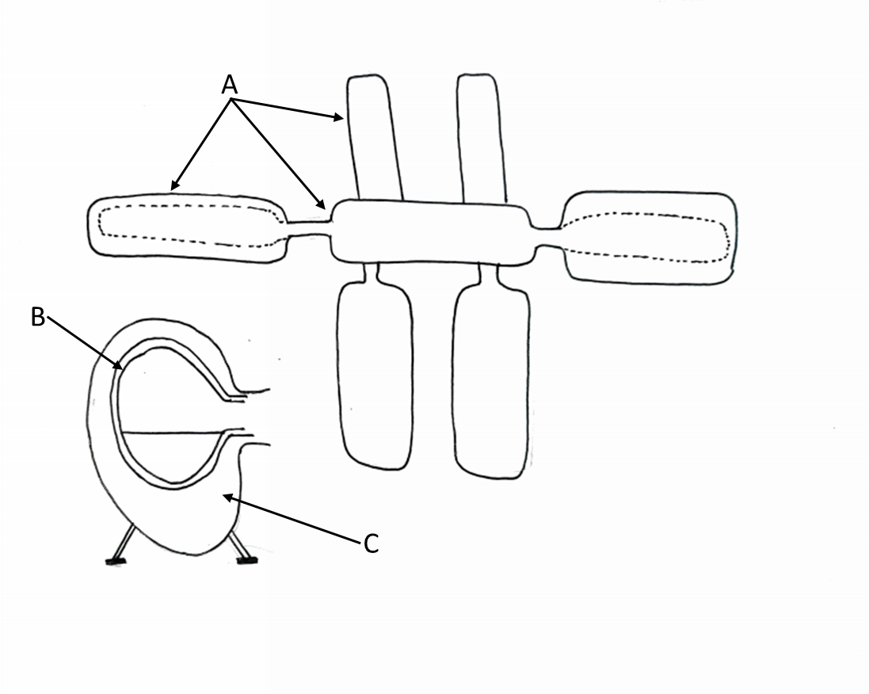
Figure 19: Modular Spider
Legend:
A – Modular structures
B – Foam glass
C – Regolith shielding
Description:
This structure used a central hub as the linking base and connects to multiple little structures. The assembly time could be small as the structures could be attached in modular connections. The structure is also protected with foam glass insulation and uses regolith on the exterior.
Advantages:
Ease of assembly.
- Expandable design.
- Uses lunar resources – saves cost.
- Better performance during emergency – Crew can move to another module if one malfunctions.
- More room for a full botanical air filtration system.
Disadvantages
- Uses more resources to cover the surface area
- Requires many more systems for additional rooms.

Full System Design #7: Babylon 6
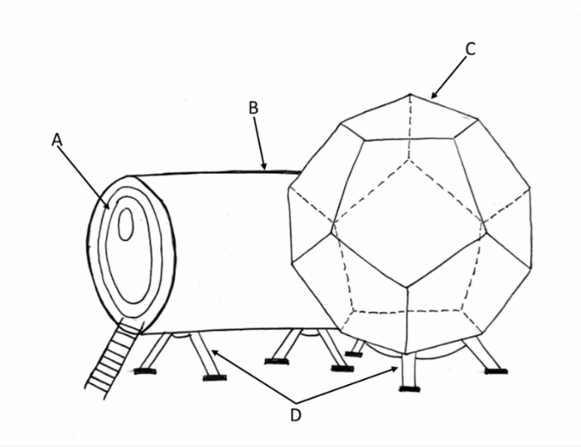
Figure 20: Babylon 6
Legend:
A – Airlock
B – Pressurized cabin
C – Dodecahedron structure
D – Stilts
Description:
The structure shown above is a combination of a dodecahedron structure with a cylindrical structure attached for entry. The Dodecahedron structure is designed to save space and add 2 floors of available space. The stilts provide added support for the structure as well as limit the thermal conduction from the ground.
Advantages
- Uses a dodecahedron structure that is structurally strong for transport and internal air pressure.
- Plenty of space for systems and human factors.
- Uses regolith to shield from harmful radiation.
- Ease of assembly
- Minimal potential for air loss due to the structural rigidity.
- Second best space saving design.
- Reusable.
Disadvantages.
- Needs to be assembled in space, Number of man hours in space increases cost.
- Not a modular design, thus, no room for expansion.

Full System Design #8: Space Valkyria
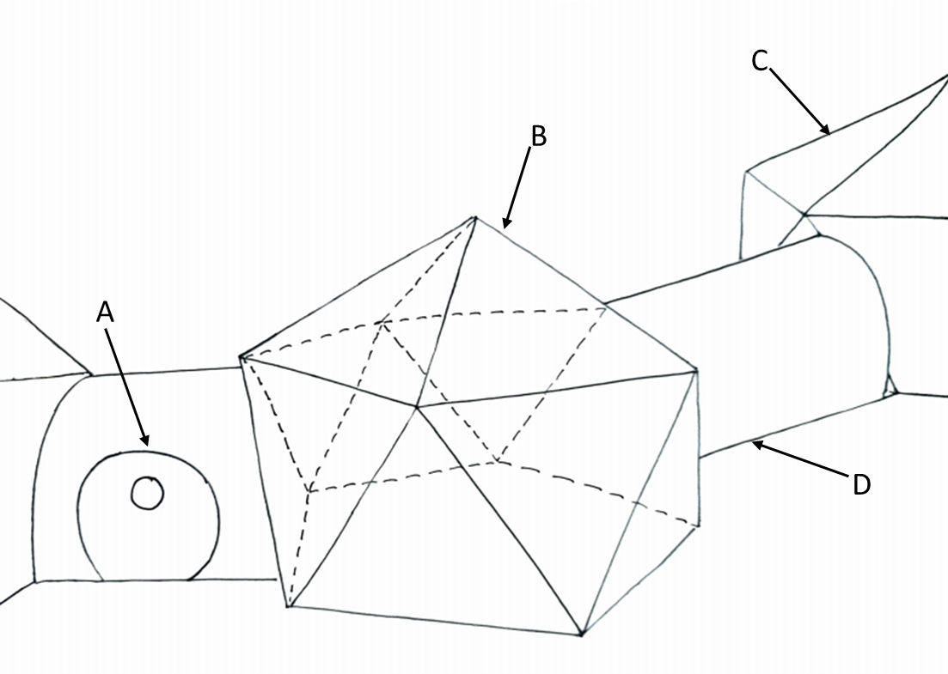
Figure 21: Space Valkyria
Legend:
A – Airlock
B – Icosahedron structure
C – Other structures
D – Pressurized connector
Description: Structure shown above is a Icosahedron structure that has a modular attachment to it. The airlock door is a cylindrical structure aiding for minimal air loss. The modular design adds extra space for additional systems.
Advantages
- Uses a dodecahedron structure that is structurally strong for transport and internal air pressure.
- Plenty of space for systems and human factors.
- Uses regolith to shield from harmful radiation.
- Minimal potential for air loss due to the structural rigidity.
- Reusable.
Disadvantages.
- Needs to be assembled in space, increasing the number of man hours increasing cost.
- Not a modular design, thus, no room for expansion.
- Lengthy assembly time.
- Increases surface area which increases potential exposure to radiation.

Full System Design #9: Stack-able Space Cube
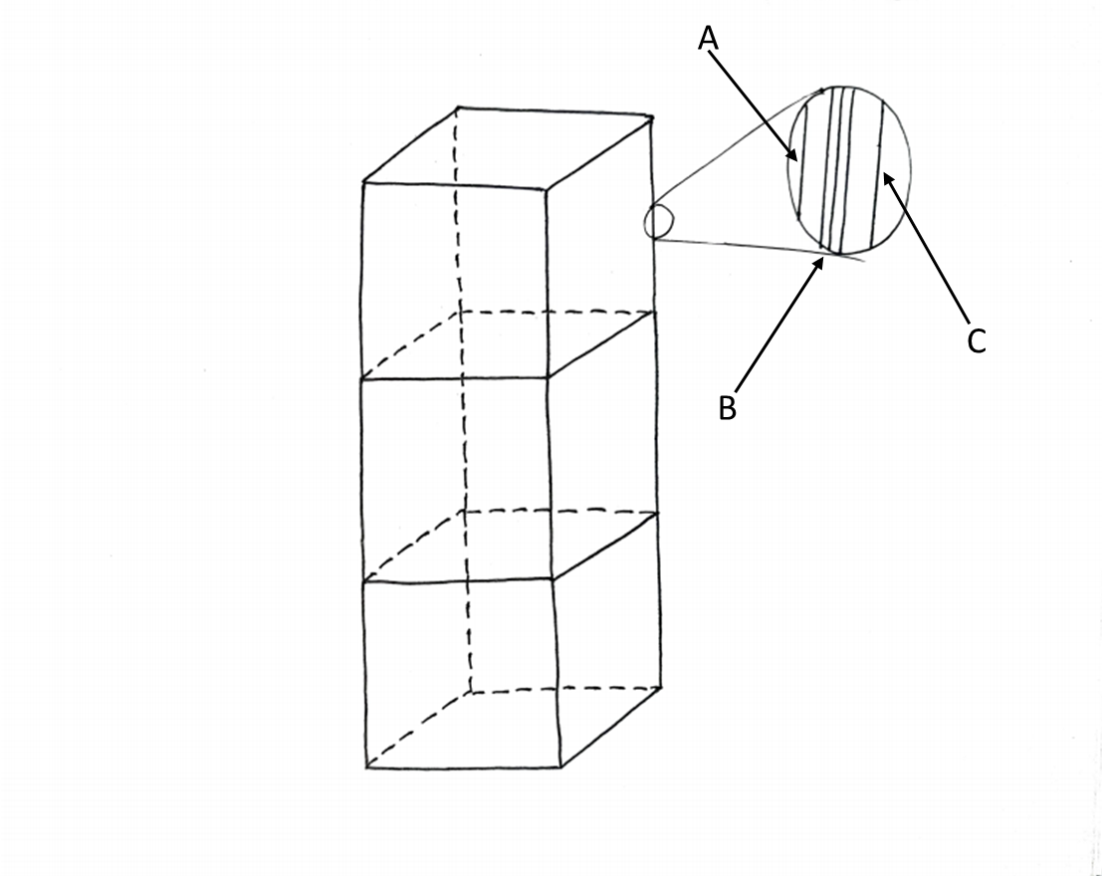
Figure 22: Stack-able Space Cube
Legend:
A – Inner Aluminum wall
B – Kevlar
C – Outer Aluminum Wall
Description: the above structure is a modular cubical structure that is stackable in space. The structure is made up of Kevlar material.
Advantages
- Stackable cubical structure.
- Kevlar is light.
- Easy to assemble on earth and transport it to the lunar surface.
- Easy to assemble on the lunar surface.
- Room for systems.
- The stackable design adds weight on to the structure resisting the air pressure at the bottom modular box.
Disadvantages.
- Not enough protection from solar radiation.
- Kevlar is expensive.
- No sub-systems present.
- Requires stairs to travel up and down.

Full System Design #10: Space Cylinder
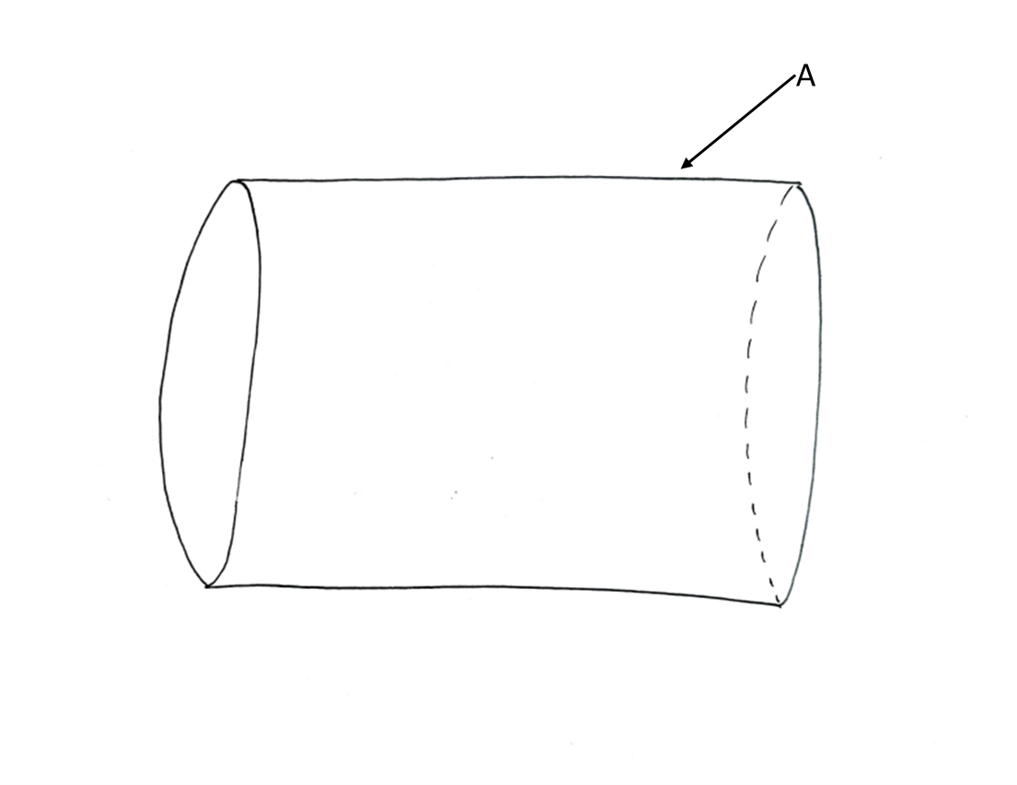
Figure 23: Space Cylinder
Legend:
A – Regolith covering
Description: The structure above is a cylinder that made out of concrete regolith. Using regolith as a base material, the concrete habitat will be structurally rigid.
Advantages:
- The regolith helps with Radiation Shielding.
- The cylindrical geometry helps spread the internal forces evenly.
Disadvantages
- The habitat is made out of concrete and concrete will require heavy labor.
- Additional materials such as cement and gravel may need to be transported to the lunar surface.
- Although the geometry helps with containing air pressure, the habitat needs constant supervision for air leaks as concrete could be porous on the lunar surface.
Concrete absorbs heat at a much higher rate from solar radiation even with the addition of regolith.

Subsystem Concepts

Subsystem #1: Power Generation and Storage

Design #1: Small Nuclear Generation: NuScale Power Module
Nuclear power generally takes up vast amounts of space and requires constant supervision by a team of engineers. However, NuScale is developing a smaller power module for homes and factory environments. The power module is scalable to size in theory. The power module is currently in development and an operational product is due in 2024. If the technology is indeed scalable, it can be small enough to fit into the habitat. The power system also offers constant power supply and can be a suitable alternative to solar power. However, the power module has a high risk of failure as we do not yet know how the module would function on the lunar surface. The module would also produce vast amounts of water wastage [36].

‌

Design #2: Solar Panels
Solar panels utilize solar radiation to generate electrical energy. Spacecrafts typically use the radiation in two ways. First to run the sensors, to heat the habitat and to run the systems necessary for life. The other is for electric propulsion. Since the application here is for lunar habitat, propulsion is not necessary. The main advantage of solar power is that it is a constant power source, light and takes up a large surface area that would provide additional shielding from harmful radiation. Disadvantages include not being able to turn the power off and the heavy batteries necessary for storage.

Design #3: Hydrogen Fuel Cell
Hydrogen is the most abundant material on the planet. It is a cleaner way to produce power and provides many benefits if utilized right. Hydrogen fuel cell use hydrogen reaction to produce electricity and produce water as a byproduct. It is small enough to be fitted into a habitat and provide a constant supply of power if hydrogen is present. A key disadvantage is that hydrogen and oxygen that is stored for use by the crew would be used for power instead.

Subsystem #2: Insulation Material

Design #1: Lunar Regolith
One of the most prominent insulation designs for the lunar habitat is using Regolith. The lunar soil has proven to be a sustainable solution through its core strength to keep the astronauts safe from the harsh conditions of the Moon and solar radiation. During the Apollo 15 and 17 missions, multiple in-depth studies were conducted on Lunar Regolith, and it's been determined that the best approach to using the soil as insulation is to create two different layers amongst the insulation, a fluff layer on the outer edge and a more compacted inner insulation. The fluff layer consists of a lower thermal conductivity ranging between $0.9×{10}^{-5}$W/cm K at 0K and $3.0×{10}^{-5}$ W/cm K at 400K while the higher compaction level maintains a thermal conductivity of $0.93×{10}^{-4}$ W/cm K at 0K and $1.94×{10}^{-4}$ W/cm K at 400K. Through only 2 cm of fluff, the outer regolith layer reduces the temperature by 25% due to the higher temperature shielding. Lunar Regolith has a prominent property of reflecting a portion of the solar radiation back out to space while absorbing a majority, the absorption constant for regolith is .87. When dry casted for 72 hours at 60 degrees Celsius, the regolith has proven to sustain a compressive strength of 37.07MPa. Although there are many advantages to regolith, the lunar soil is only sustainable for certain objects; scientific equipment like telescopes for example cannot be covered in regolith. [40]
Table 4: Regolith Thermal Properties
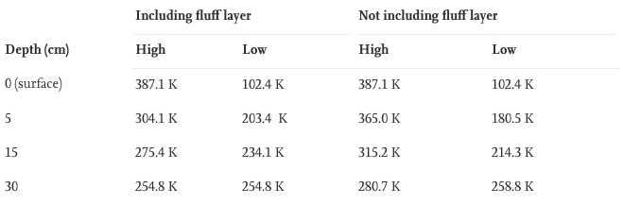

Design #2: Multilayer Insulation (MLI)- Mylar
Thermal multilayer insulations are designed to maintain the internal temperature while reducing heat loss. MLI consist of numerous reflecting radiation shields interspaced with a low conductivity thermal spacer. [SG7] The insulation material also includes heat radiation throughout the gaseous medium while heat conduction is maintained within the spacer or contact points through the crinkled MLI exterior surface. The radiation shield of the insulation is the most prominent component of the insulation, Mylar is an extremely inexpensive material option and has been mass produced. Although, the material is extremely vulnerable to extended UV exposure. Thus, this material is more commonly used within the insulation. [40]

Design #3: Multilayer Insulation (MLI)- Kapton
This gold-colored plastic is one of the most prominent insulators through its increasing emissivity the thicker it gets. Although Kapton (1.42 g/cm^2) is slightly heavier than Mylar (450g/m^2), the material is still more rugged and temperature resistant. Kapton has a temperature range of -276 degrees C to 400 degrees C. [SG8] Although tested to be very effective, the ISS solar array wing, aluminized in Kapton, has also degraded through undercutting erosion.

Subsystem #3: Environmental Control

Design #1: ISS – Water Recovery System (WRS)
The Water recovery system (WRS) on the ISS is a procedure to reclaim wastewater, cabin humidity condensate and extra vehicular activity (EVA) wastes. The system initiates with a water processor that separates free gas and solid materials such as lint, hairs, etc. then proceeds to a series of multifractional beds that extend the purification procedure of the water. A high temperature catalytic reactor assembly removes any remaining microorganisms and organic contaminants. Typical contaminants increase the increases the conductivity of water; thus, conductivity sensors test the purity of the water. If the water does not pass the standard for health and safety of the crewmembers, the process is conducted again, then stored in a storage tank ready for use by the crewmembers. Through this process, the delivery of drinkable water sent from Earth to the ISS to support six crew members is reduced by 15,000 pounds per year. Some of the main disadvantages for this design is reclaiming above 90% of the human waste through the filtration recovery system. The reliability of this design is also at risk while having difficulty to expand.

Design #2: ISS- Oxygen Generation System (OGS)
Throughout the daily operations on the ISS, breathable oxygen is lost due to the habilitation, experimental use, airlock depressurization, module leakage, and carbon dioxide ventilation. The oxygen generation system reinstalls the lost oxygen mainly through its cell stack which electrolyzes the water provided by the WRS, yielding hydrogen and oxygen as its byproducts. The oxygen generation system is designed to operate at cycle or continuously, providing a maximum of 20 pounds of breathable oxygen every day during continuous usage or at a normal rate of 12 pounds of breathable oxygen during cyclic usage. [SG10] The following figure provides a visual representation of the flow chart within the ISS, incorporating the WRS and OGS. Some of the challenges engineers face with this method is providing the high pressure and high purity air that would best fit the astronauts while sustaining a durable design. [41]

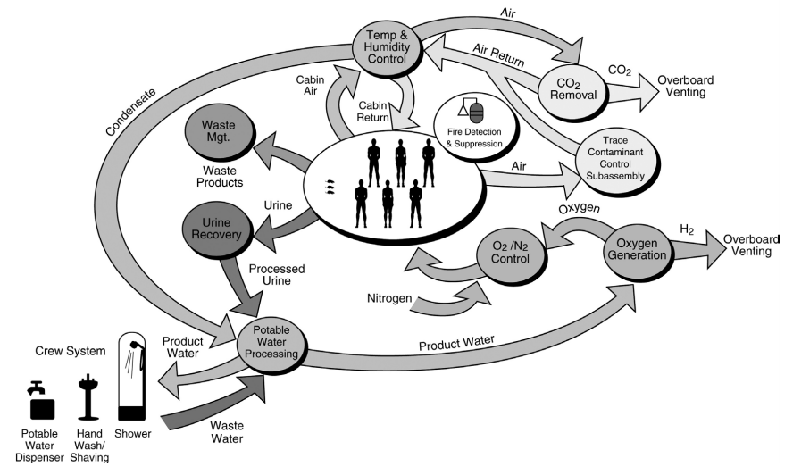
Figure 24: Regenerative Environmental Control Within ISS

Design #3: Spacecraft Atmospheric Monitor (SAM)
The spacecraft atmospheric monitor (SAM) is a mobile measurement tool used in outer space to effectively test atmospheric properties such as pressure, radiation, etc. SAM is a compacted gas chromatograph mass spectrum designed to map out organic compound’s major factors of the spacecraft’s atmosphere. This monitor weighs approximately 9.5 kg and has the potential to make a measure constitute analysis every 2 seconds which is a drastic decrease in time compared to its predecessor which took 3-5 hours while also decreasing in volume to 10 L which is also a 1/6 decrease. SAM will intake common air constituents such as CH4, CO2, H2O, O2, and N2. This design has the stability to currently run-on full potential for a maximum of two years, then requiring replacements of certain components making it not very sustainably practical.

DESIGN SELECTED – First Semester
In this section, the Pugh matrix and the Decision matrix are provided first. Then the selected final concept is also provided with a rough cad model and the rational for the concept selection.

Technical Selection Criteria
Making the right decision on a concept is essential to move forward on a project. The best way to evaluate the pros and cons of a design is achieved using a Pugh matrix and Weighted Decision Matrix.

The first part of the concept selection is the Pugh Chart to narrow down concept variants for a weighted analysis. The selection criteria were taken from the list of engineering requirements in the order of importance. Then we conducted the Pugh Chart from using the concept variant 15 as the datum and assigned a score to each concept variant. The concept 8 was used as the datum to evaluate the remaining concepts. The 6 best concepts were then selected with the highest net score out of all the concept variants for the next stage of evaluation. For the first selection we choose the CV’s with the highest net score out of all the CV’s.

As shown below in Table 5, the concept variants were narrowed down from fifteen to the six top concept variants. The selected concepts are highlighted in green. A full-size table is provided in the Appendix A.
Table 5: Pugh Chart
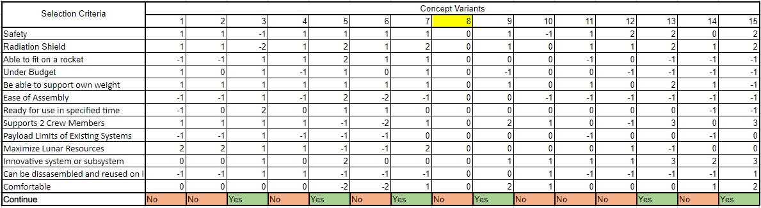
The customer criteria were revised in the later part of the semester as more analysis was conducted. The previous iteration of criteria was shown here for accuracy.

The next stage of selection is the weighted Decision Matrix. The top six concept variants, as chosen by the Pugh Chart, are then evaluated for each criterion. There are a total of fourteen weighted requirements and the individual criteria were weighted according to the importance for the scope of the project and the concept variants are evaluated according to that weighted criterion as shown in Table Xb. The criteria for the decision differ from those used for the Pugh Chart. In the Pugh matrix, the team looked at how the concepts differ from one another. As a result, the team chose the general customer requirements to use in the comparison. In the Decision Matrix, the criteria were selected based upon the engineering requirements and modified to compare how each design would satisfy the criteria the best. The weighted Decision Matrix is presented in Table Xc.

Table 6: Weighted Requirements
Requirement | Weight (%)
Limiting Radiation Exposure | 12
Minimum Habitable Volume (50m3) | 12
Maintain Constant Air Temperature | 10
Inside Air Pressure | 10
Structural Integrity | 8
Ease of Assembly | 8
Limiting Potential Air Loss | 8
Total Cost | 6
Payload Limits of Existing Systems | 6
Maximize Lunar Resources | 6
Innovative system or subsystem | 6
Disassembly and reusability | 4
Comfortable | 4

Table 7: Weighted Decision Matrix
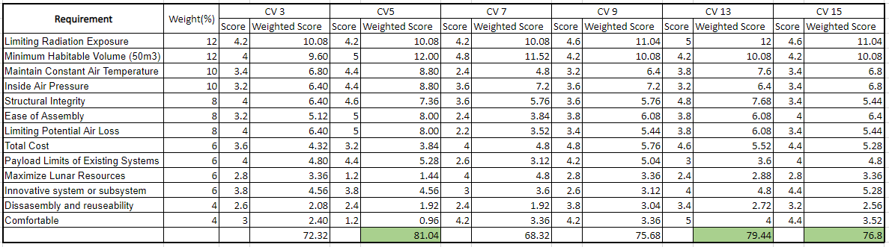
The requirements accounted for above were revised in the later part of the semester as more analysis was conducted. The previous iteration of requirements was shown here for accuracy.

As shown in the Tables above, the selected concepts are the concept variant 5 (CV5) and concept variant 13 (CV13). Initially, CV5 was favorited for the overall versatility of the design. However, after analyzing CV13, it was realized that some of its advantages could be combined with CV5 to make for a complete well-rounded design. A key advantage of CV13, compared to that of the other concepts, is the ideal use of space and a sturdy structural integrity achieved by using a dodecahedron support structure. Furthermore, the potential ease of combining multiple structures to form a modular design could not be overlooked. These two advantages prompted us to combine CV5 and CV13 to form the final selected design. A detailed preliminary Computer Automated Design (CAD) model can be found in Figures XA to XD and a description of the design are provided below.

Rationale for Design Selection
Final Design Selected: Modular Space Capsule
Design Description: The design shown below is named the Modular Space Capsule. As shown below the on the outside is a big cylinder with a window section at the end. The design is generated from CV5 and CV13 and is designed for versatility with assembly. The structure is manufactured on earth and initially assembled on earth for testing. After the testing process, the structure could be taken apart and shipped to space in rockets in modular sections for assembly in space, or on the moon. Another option is to place the structure in a rocket fully assembled and transport it to the lunar site of interest. Currently, all the sub-systems necessary to support 2 individuals exist inside the structure. In addition, the capsule is designed to be a expandable via the airlock chamber where it could use a coupling chamber to connect to extra modules if necessary.
A list of the top four human factors as described by the research as described in section 3.1.2 is presented below:
- Net Habitable Volume
The generated concept structure must adhere to the minimum habitable volume (NHV) to accommodate for a safe livable area. According to human factors research, our net habitable volume for 2 individuals for 30 days is 55 +/- 5 cubic meters. This net volume not including the air lock chamber is 3m x 7.5m x 2.5m (width x length x height). This results in a volume of 56.25 cubic meters. The structure is divided in three quadrants based on human factors research. As shown in the figure below, the first quadrant is separated for necessary subsystems. The second quadrant is separated for the workspace and the last quadrant is separated for the living quarters.
- Workspace
The workspace area is in the second quadrant of the final concept design. The workspace accounts for laboratory equipment and storage of materials collected on the lunar surface.
- Main Systems Area
The subsystem area contains the air management system, water purification system, power storage, temperature control system and pressure management system. The waste management system is planned to be placed in the hygiene area.
- Personal Living Quarter
The personal living quarter consists of the capsule bunk bed area, the food preparation area, and a hygiene area. The waste management system and water purification systems are located in this quarter.
The rational justifying the selection of the final concept for the design selection was based on the main criteria as described above in the criteria ranking. The reasons why the selected design sufficiently achieves most of the criteria compared to that of the other designs is discussed below:

Regolith is an ideal insulation material that is abundantly present on the lunar surface as it is efficient at shielding the structure from harmful radiation. As a result, this material has been used in multiple designs in varying capacity. The chosen method of application here is to pack it in bags and place it around the structure and then spray the regolith into the remaining crevices. Regolith also compresses down on the structure helping negate the internal air pressure. Furthermore, regolith will not be added to the dry mass limit of the structure allowing for additional overall cost savings as this material is readily available on the lunar surface and does not need to be transported on a rocket from earth unlike the structure. The structure also uses ultra-lightweight mylar for emergency shielding if the regolith is blown away due to unexpected events.

The structure meets minimum habitable volume requirement and allows room for expansion if needed. The design also provides adequate space for all the systems to function allowing for an entire section of the floor to be used for air and water filtration systems. As seen in the cross section of the generated.

The structure is small enough to fit inside a rocket and is manufactured on earth. This means it could be assembled on earth to be transported to the lunar surface as a whole or it could be assembled on the lunar surface. The structure also uses the space grade circular tubing truss attachment that is capable of one-handed assembly. This shortens the assembly process.

The geometry of the structure is made from a honeycomb structure which helps save the most space while also being structurally rigid. The structure also distributes the internal air pressure evenly throughout the structure minimizing air loss. In addition, the honeycomb structure also handles the massive vibrations from the rocket’s acceleration better than any other structure.

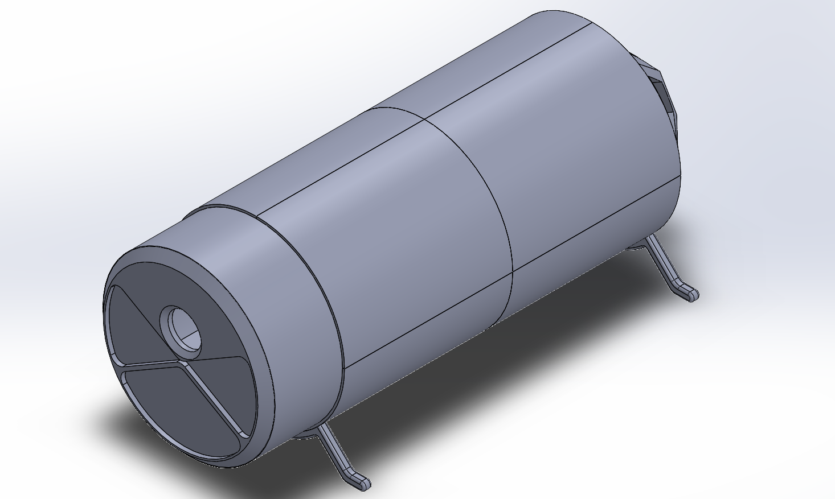
Figure 25: Isometric view of the front of the preliminary CAD model generated in SOLIDWORKS.

Figure 26:. Isometric view of the rear of the preliminary CAD model generated in SOLIDWORKS.

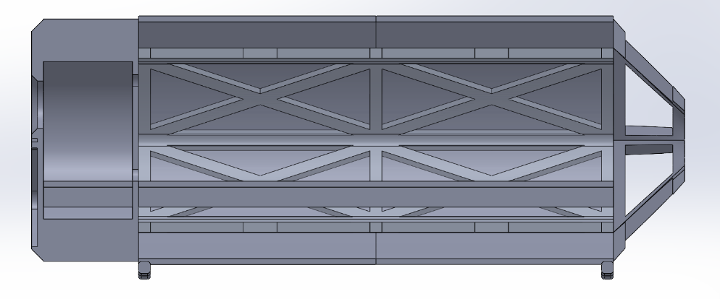
Figure 27: Cross-section of the preliminary CAD model generated in SOLIDWORKS.
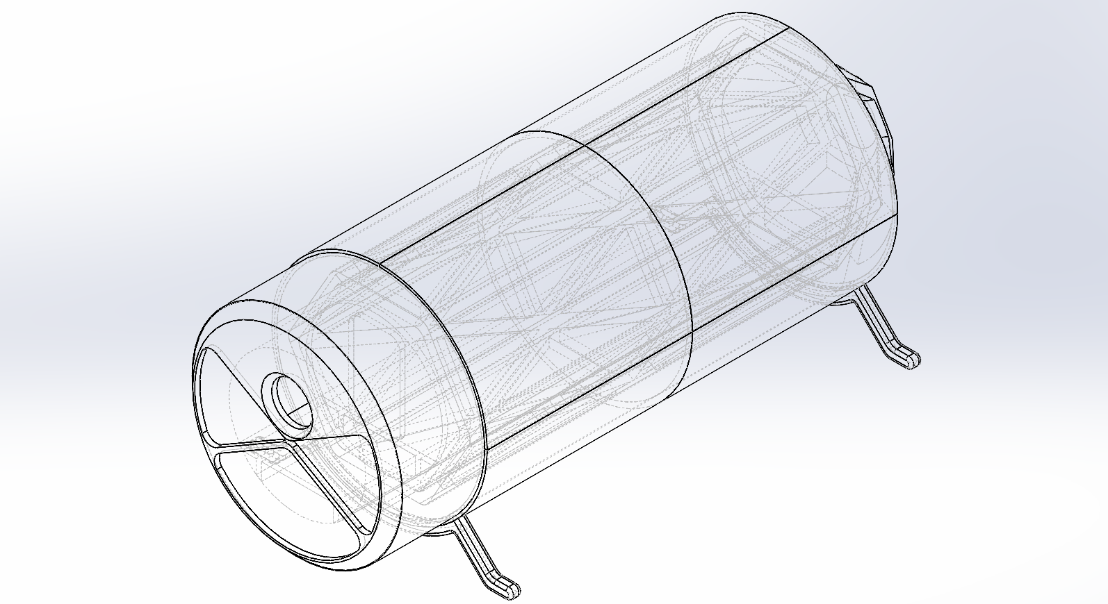
Figure 28: Skeleton (hidden lines shown) isometric view of the front of the preliminary CAD model generated in SOLIDWORKS

IMPLEMENTATION – Second Semester
Several design changes were made this semester to improve the design further. Specifically, the team changed the bone structure, Whipple shield, and pressure wall significantly. Further design changes were made to the supports, floor, as well as to the air lock model.

Design Changes in Second Semester
The team made several design changes in the second semester to better fulfill the engineering requirements.
The lunar habitat has gone through a substantial makeover in the past several weeks. Both major and minor changes were made to the design based off meeting engineering requirements, FEA (Finite Element Analysis) analysis, and learning manufacturing techniques from constructing the scaled prototype. Some of the larger changes include redesigning the bone structure, removing the internal wall, and redesigning the Whipple shield. The remainder of the design changes are minor and were made to work with the new major changes made. Certain design changes were implemented to the physical prototype the team is designing to save costs and make the process feasible.

Design Iteration 1: Bone Structure
[Briefly describe what the original design was, and the change made for this particular component or subsystem.]
[Provide pictorial evidence of the differences (through product photos, CAD iterations, etc.) and justification of the decisions behind the changes.]
Two key design iterations were conducted on the bone structure. The first pertained to the cross section of the bone structure. Initially, the bone structure was designed as rectangular beams. After the implementation of the pressure wall, the plate structure carried too much weight. As a result, the structure was changed to circular tubing which is easier to weld and would limit stress concentrations. The figures below illustrates the previous and latter designs.
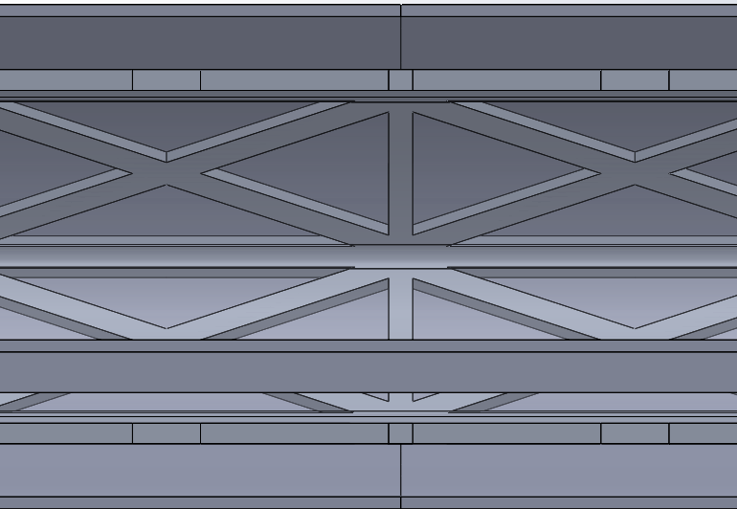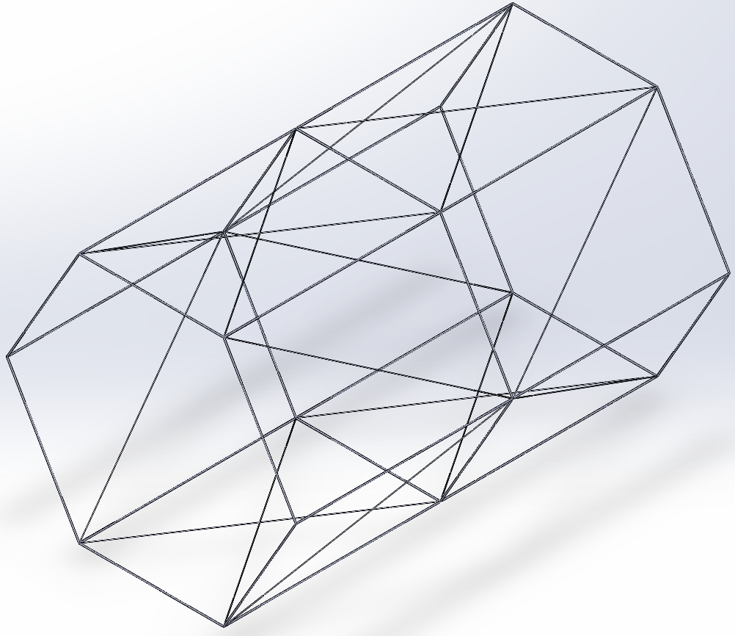
Figure 29: Bone Structure Design Change

In addition to the cross section, the hexagonal shape of the bone structure was analyzed to improve the integrity. A key assumption was that the weld material used was assumed to have the same properties as the metal itself. The figure 30 below illustrates the analysis done on the one of the subsections of the bone structure. The force chosen was calculated from the internal pressure of 101300 N/m2 * half the surface area the beam.

The force calculation is a back of the envelope study that allowed us to pick a better thickness for in depth analysis. The in-depth analysis could not be conducted as Solidworks still couldn’t mesh the full-scale model well. Thus, the model was broken down to just the hexagonal region. The forces then were calculated as such.

F=101300Nm2∗226.2m²∗13∗16
=3.819 MNF
=101300Nm2∗226.2m2∗13∗16
=3.819 MN

Using the force value above, four forces were applied on each part of the beam resulting in critical stress concentrations to improve load path clarity. However, the structure handled this well and supports might be necessary for the system to work. The study was conducted for titanium and aluminum. However, at the thickness prescribed 6061 T6 Aluminum alloy was chosen. The image below illustrates the study on the hexagon.
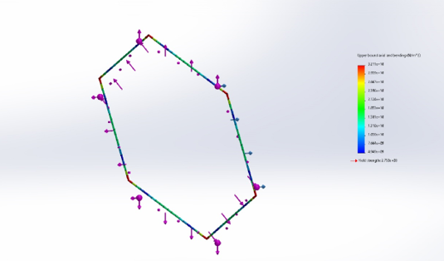
Figure 30: Hexagonal Section of Bone Structure

The window got a makeover, the frame of the window is now welded to the end of the bone structure. The ISS style window on the habitat went through a small redesign in the latest iteration. It was newly redesigned using the Solid works weldments feature; meaning the new frame for the window is built into the bone structure. This redesign saved 164.88kgs. Figure 12 and 13 below shows the before and after images of the new frame with the built-in window frame.
Figure 31: Previous CAD model of the Frame
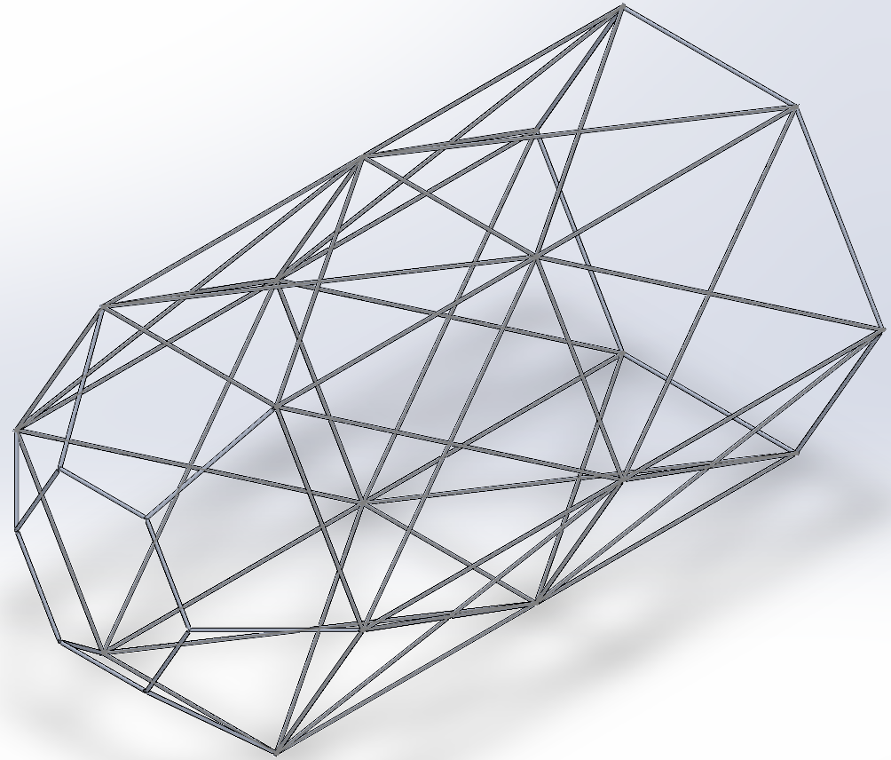
Figure 32: Updated Frame with window CAD model

Design Iteration 2: Whipple Shield
The original design for the Whipple shield consisted of 80 components that had five layers of different materials. A single shield had one front bumper, three intermediate bumpers, and a rear bumper which would be made from aluminum 7050, a combination of Kevlar and Nextel, and aluminum 7050 respectively. Each bumper would have a spacing of 3 (cm) between itself and the next bumper for a total of 12 (cm) between the front bumper and the rear bumper. We included as much space between each bumper (otherwise known as the standoff distance) as possible (comparatively speaking with the I.S.S) because the greater the distance between each bumper the lower the impact force of the hypervelocity object. As shown in Figure. 8 we originally wanted to create a shield with a square pattern to benchmark more closely to the International Space Station (I.S.S). However, this design was quickly changed since our habitat has a cylindrical geometry.

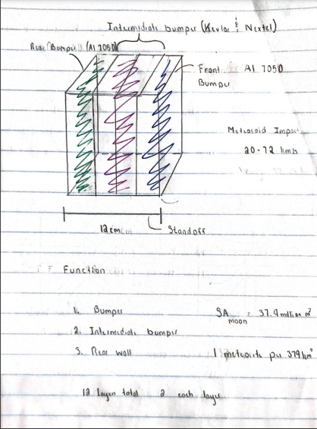
Figure 33: First Iteration of the Whipple Shield

To adapt the shield to the geometry of the habitat it was designed with a partial cylindrical shape ranging from -40º to 225º. This range was to account for virtually every realistic area where the habitat could be impacted by a hypervelocity object (i.e., micrometeorite). However, as the team negotiated the designs of the shield it was our opinion that the habitat would not take significant damage (or any at all) below 0º to 180º. So, the shield was the re-designed to be the length of the habitat in the shape of a semicylinder as shown in Figure 9. (it is worth noting that none of the original dimensions have changed from the original design). We also chose to swap aluminum 7050 for aluminum 6061-T6 and the reason for this is because aluminum 6061-T6 has a much higher tensile strength, and it is also used in more aerospace applications. To save money we also switched out Nextel for Carbon fiber because it is much cheaper to purchase.

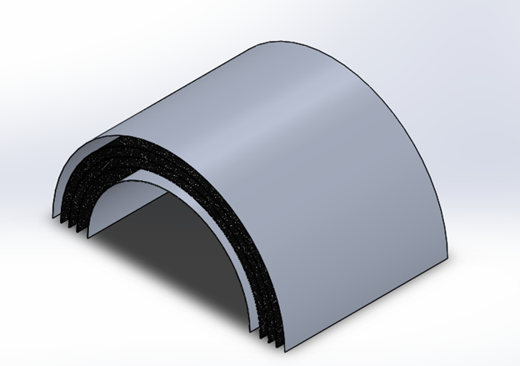
Figure 34: Second Iteration of the Whipple Shield

Since the Sun produces a lot of heat due to radiation it was important that we conducted a thermal analysis to simulate the range of temperature that would impact our habitat. A series of thermal simulations were conducted through ANSYS (a Multiphysics modeling software) on the rear bumper as well as one of the intermediate bumpers to provide an accurate estimation as to how the materials we have chosen would withstand the radiation produced by the Sun. From these simulations we were able to know for certain that our shield would not only withstand the radiation but not change in volume either due to thermal stress as shown in Figure 10.

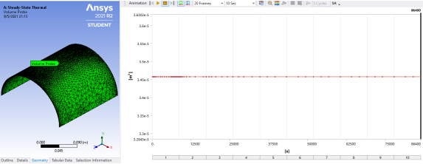
Figure 35: Volume changes due to thermal stress

Our last and current iteration of our Whipple Shield came from an idea that Professor Willy provided us during one of our staff meetings. He proposed that instead of a cylindrical design that would only protect the upper portion of the habitat we could re-design the shield in the shape of an “A”. In short, the shield would now have a rectangle geometry which would be placed along the hexagonal bone structure from edge to edge on the top half. At the vertices that separate the upper half between the lower half of the hexagonal bone structure will be hinges that connect the upper portion of the Whipple Shield to the lower portion. This lower portion of the shield will swing in and will hook into the habitat so that it can fit into the Falcon 9 rocket for transportation from the Earth to the Moon. Shortly after placing the habitat on the lunar surface the lower portion will swing open to provide extra protection from micrometeorites, provide storage space for our lunar rovers, and storage space for extra scientific equipment. Not only did this improve one of our customer requirements for safety but it also reduces the complexity of manufacturing for the prototype as shown in Figure 11.

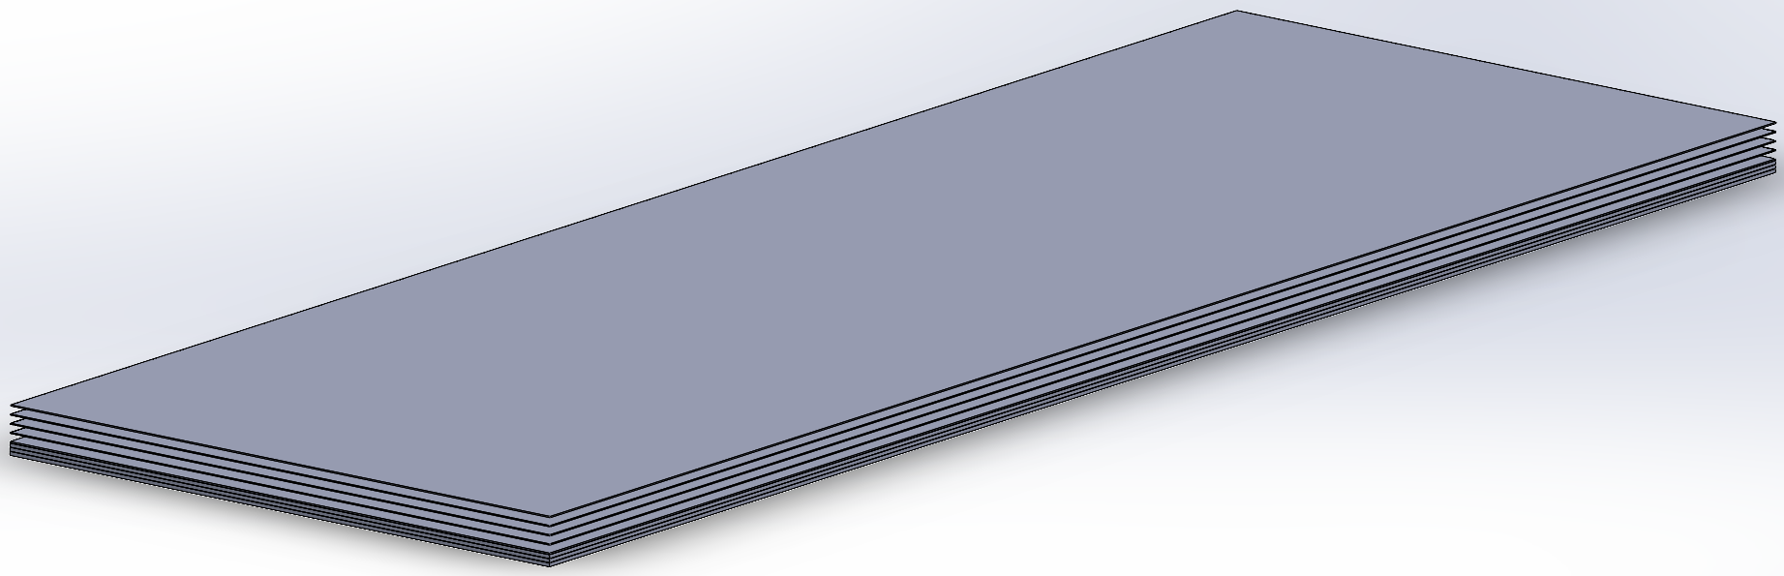
Figure 36: Mid- Fall Semester Whipple Shield CAD model (contains MLI layers)
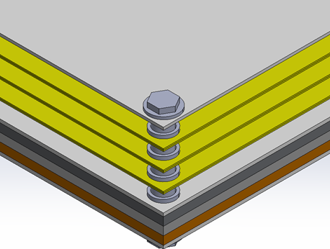
Figure 37: Whipple Shield with materials added

Design Iteration 3: Pressure Wall
The second stress analysis was conducted on the pressure wall that rests on the inside of the bone structure. If the pressure wall can handle the force well enough, it would help alleviate the force acting on the bone structure. As a result, the thickness of 2.54mm and 25.4mm were compared. The 25.4mm worked better than expected. The images from the study are illustrated below.

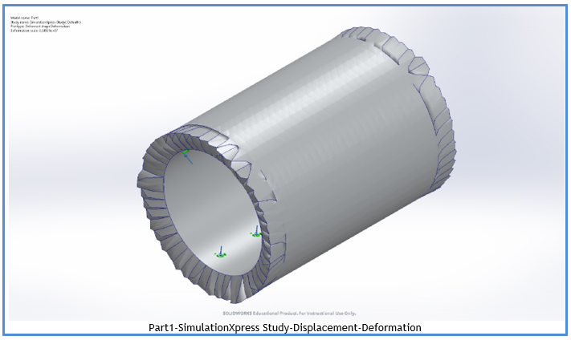
Figure 38: Displacement-Deformation results of Pressure Wall

The second study conducted compared Aluminum and Titanium. Titanium and Aluminum had similar stress and deflection parameters. However, Titanium weighed over 7000Kg. As a result, Aluminum was chosen as the ideal material for further analysis.

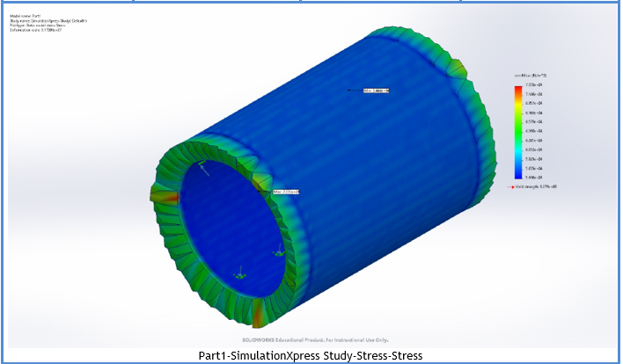
Figure 39: Stress Study results of Pressure Wall

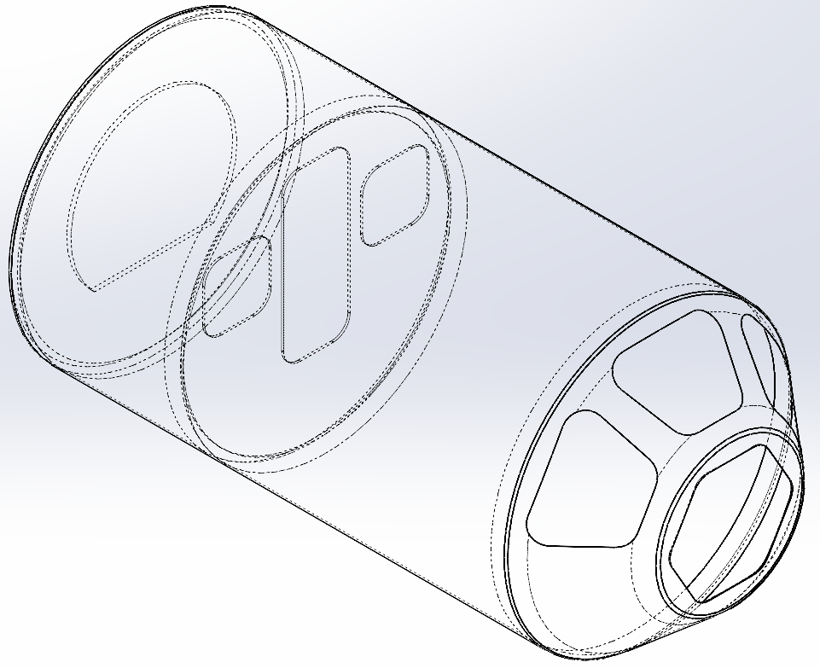

Figure 40: Hidden line Isometric View of the final Pressure Wall

Design Iteration 4: Supports
The legs are now anchors that go into the ground to anchor the habitat to the surface instead of having the habitat sit above the surface. This will reduce costs and weight. The removal of the internal wall creates a flat surface on the bottom of the habitat. The team wanted to leverage this advantage of having a flat surface on the bottom and transform the previous leg idea into a whole new concept. The new legs act as anchors that mount to the frame and are buried beneath the lunar surface. The new habitat now sits directly on the surface of the moon and is anchored by 4 “legs” mounted directly to the frame in the front and back. This adds stability to the habitat and better fulfills our engineering requirement of using lunar resources. It will also reduce the weight of the habitat.
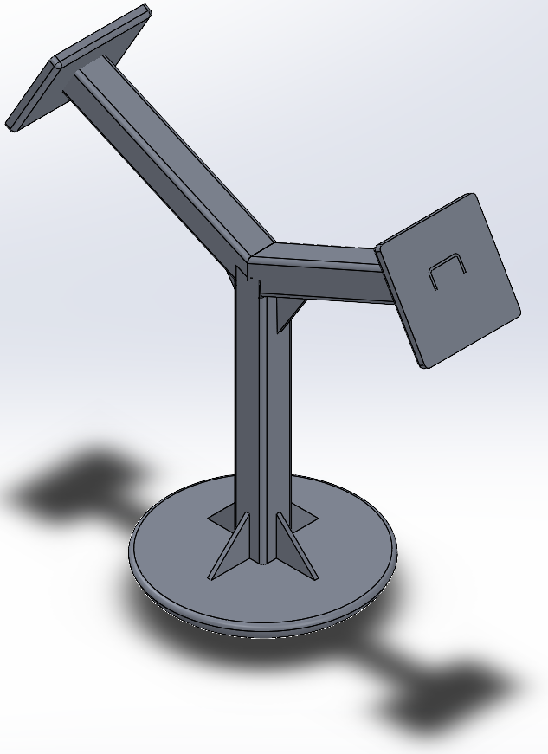
Figure 41: Supports for Lunar Habitat

Design Iteration 5: Floor
The floor design was modified from having two supports on the end and in the middle to having only one support in the middle and 2 on the edges of the floor that conformed to the pressure wall. There is an increase in storage space and the floor has been moved up. Half of the divided area will be utilized for the ECLSS, and other life configuration systems and the other half will be used for storage of simple life requirements.
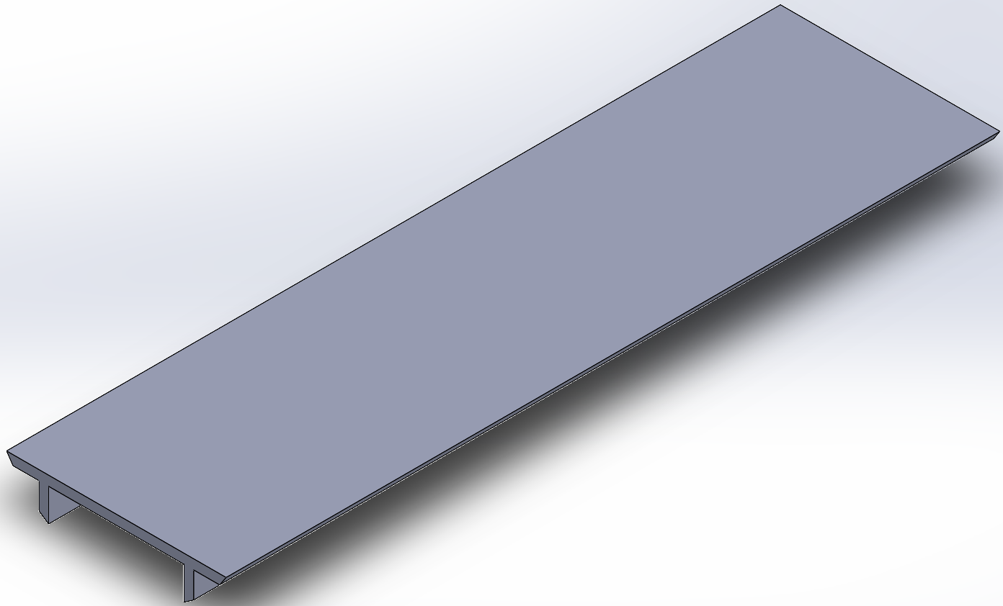
Figure 42: Previous CAD model for the Floor

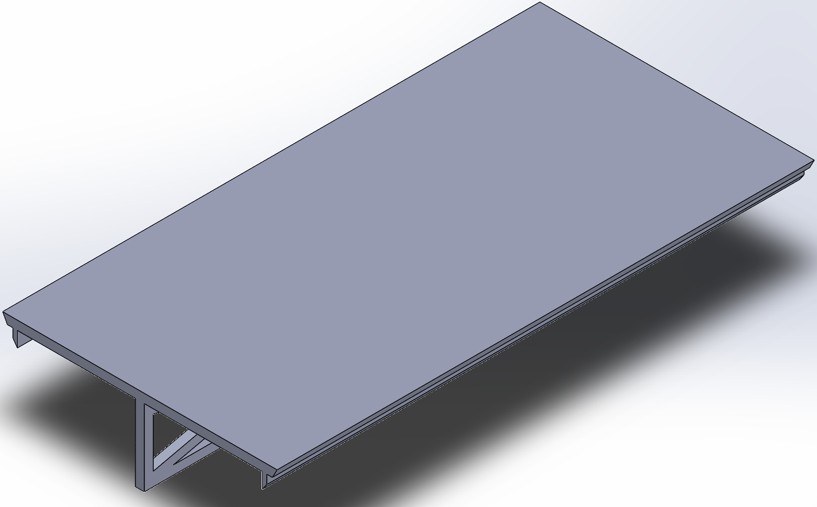
Figure 43: Mid-Fall Semester CAD model for the Floor
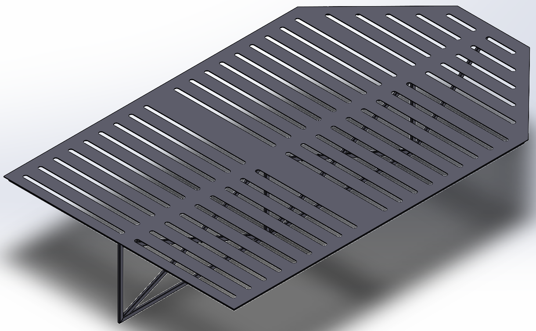
Figure 44: Final CAD model for the Cabin Floor

Design Iteration 6: Airlock
The design for the airlock mechanism of the space station will follow the lead of the new Joint Airlock which will consist of two main compartments, a crew airlock and an equipment airlock which will be a part of the lower-level storage compartment. The crew airlock will depressurize to 3 psi and slowly down to zero psi before the hatch is opened into outer space. The incorporated hatch will consume two meters of the habitat from the lower storage compartment to the ceiling of the livable habitat. The extravehicular hatch will be above the storage compartment with the opening hatch door connected outside. The mechanisms for the depressurizing/pressurizing unit and safety commissions will be held within the storage compartment area.
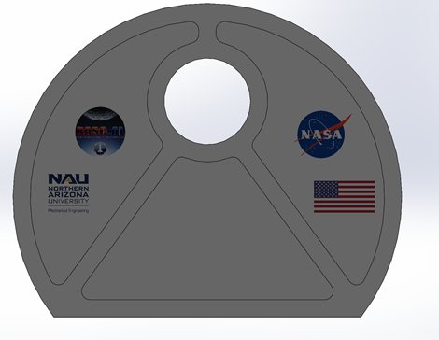
Figure 45: Front Airlock Door

1/10th Scale Representative Prototype
To get a better idea of how to realistically implement the design, the team created a 1/10th scale representative prototype to better understand the manufacturing processes required to create the full-scale habitat. The finished prototype is shown in figures X through X below.

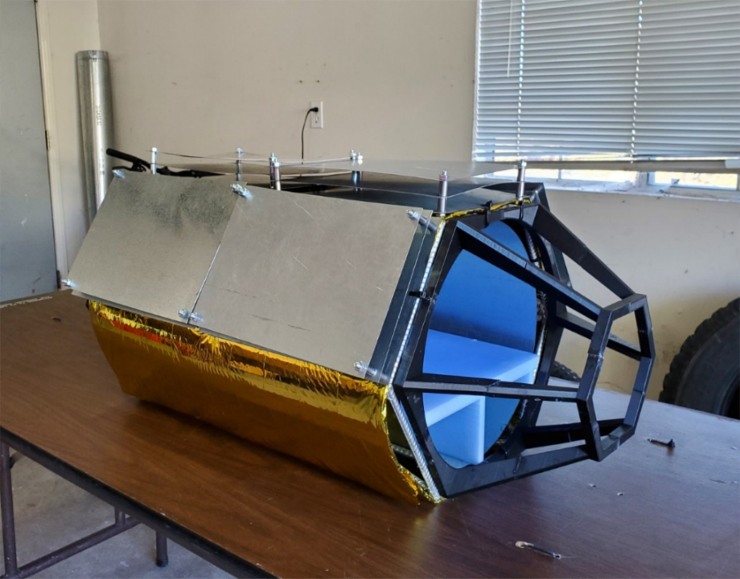
Figure 46: Final Prototype
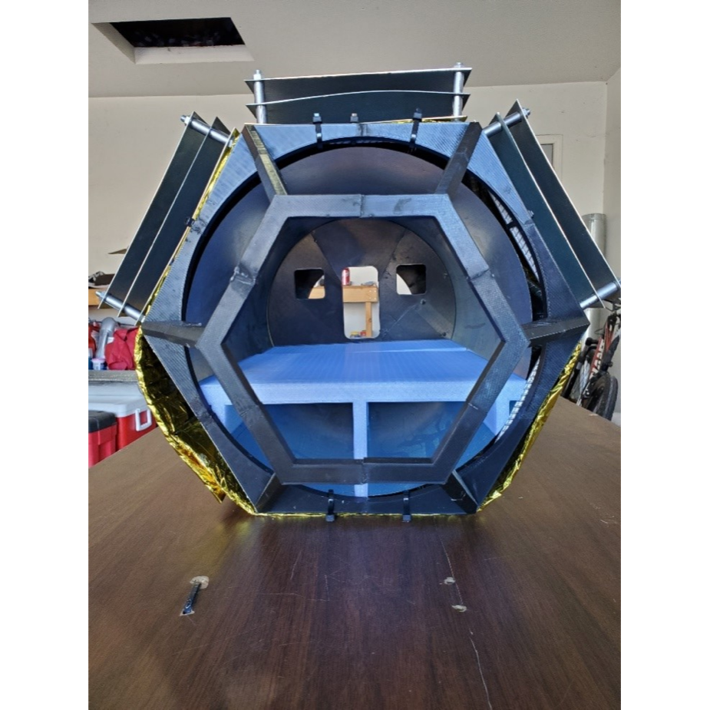
Figure 47: Final Prototype Front View
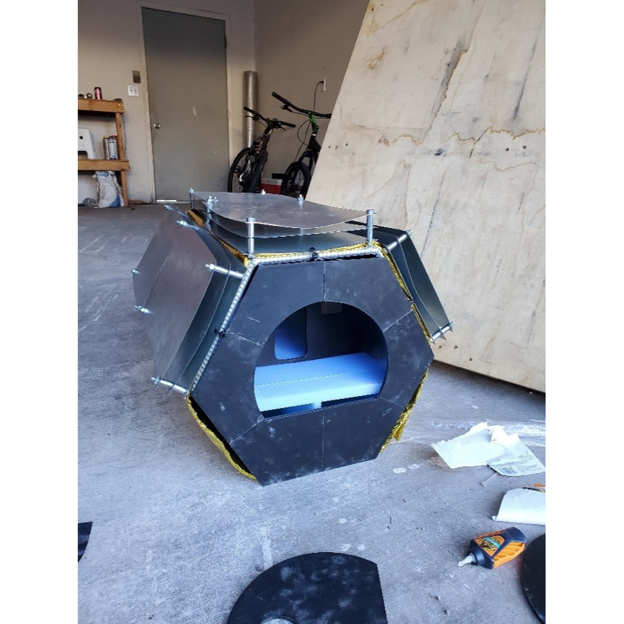
Figure 48: Final Prototype Rear View

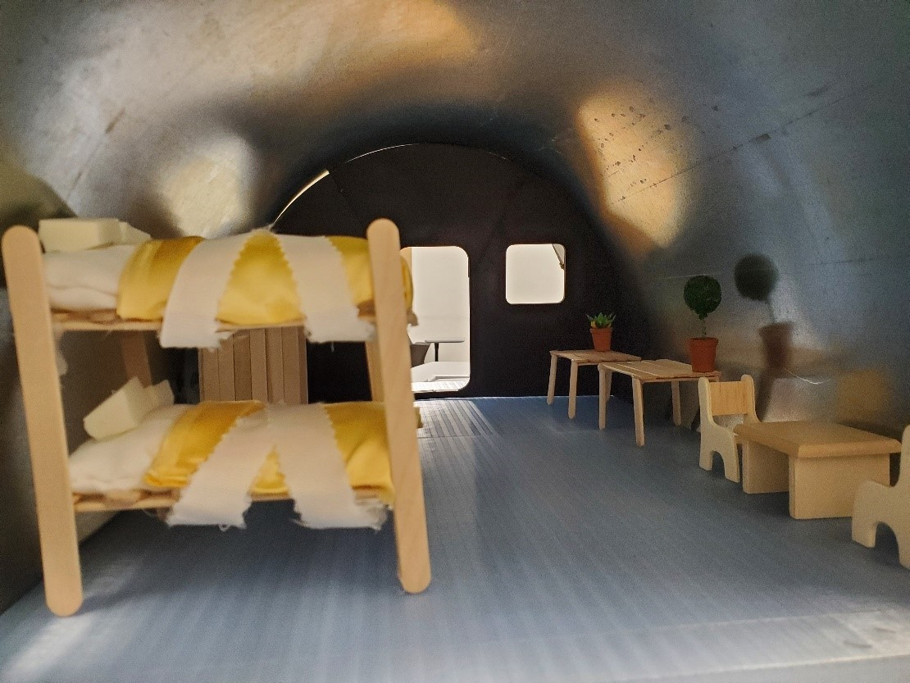
Figure 49: Final Prototype Interior View

Subsystem 1: Bone Structure and Pressure wall
The bone structure was constructed by cutting, welding, and painting #3 3/8” rebar. The bone structure was constructed with the updated bone structure iteration including the new cross members. The pressure wall was constructed out of 24 gauge galvanized steel sheet metal. The sheet metal was plasma cut, rolled, and spot welded to create the desired cylindrical shape. The finished diameter was 13” designed to fit inside the bone structure. Figure 50 below shows the finished bone structure and pressure wall.

Figure 50: Bone structure and pressure wall

Subsystem 2: MLI
The MLI was constructed by wrapping Aluminized Mylar around double reflective insulation. The mylar is intended to show the outer layer of the MLI and the DRI is intended to show the inner layers. The thickness of the insulation wrapping is around 10mm which is similar to the real thickness of the insulation aboard the full-scale prototype. Figure 51 below shows the finished and installed MLI.

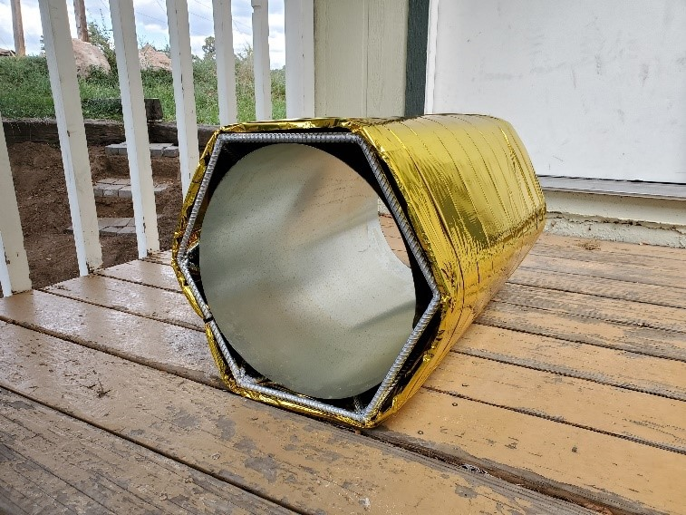
Figure 51: MLI

Subsystem 3: Floor
The floor was 3D printed using PLA at 15% infill. The model from the actual design was scaled down and slightly altered to fit the inside of the 13” diameter pressure wall. Figure 52 below shows the finished floor.
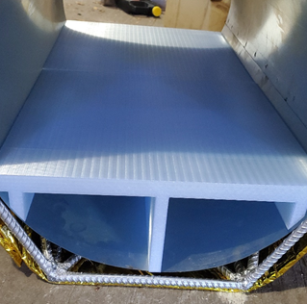
Figure 52: Floor

Subsystem 4: Whipple Shield
The Whipple shields were constructed by cutting out 27 1ft X 8-inch sheets. Each of the sheets were stacked 3 high into the shield assembly using ¼-20 threaded bolts and washers. The sheets were spaced using stainless steel spacers. Figure 53 shows the finished Whipple shield assembly.
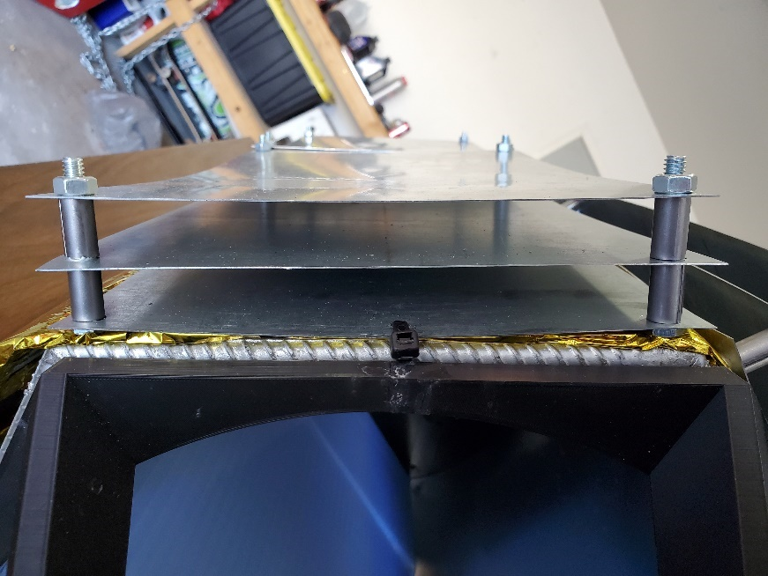
Figure 53: Whipple Shield Assembly

Subsystem 5: Window
The window was 3D printed using PLA and a 15% infill and glued together using superglue. The window was specially designed for the prototype to interface with one of the flat sides and attach to the frame. Figure 54 shows the fully assembled and installed window.
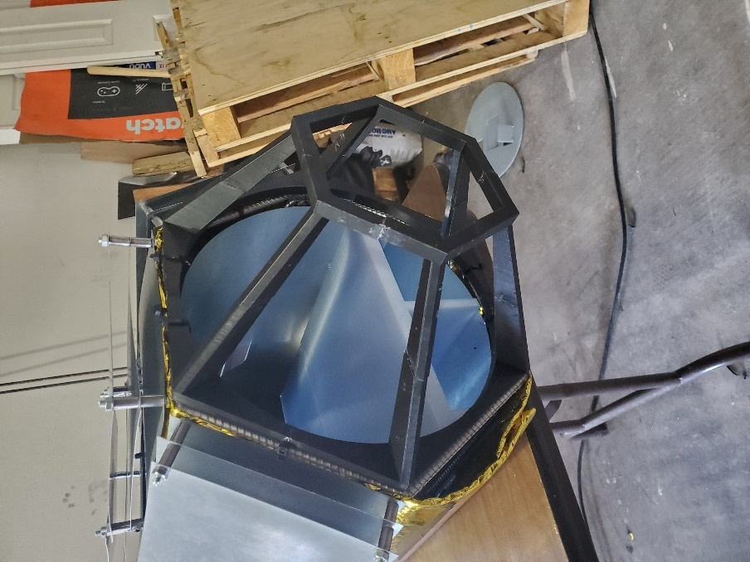
Figure 54: Window Assembly

Subsystem 6: Air Lock
The interior and exterior airlock doors were 3D printed with PLA and a 15% infill and glued together with a process similar to the window. Figure 55 below shows the finished airlock subsystem.
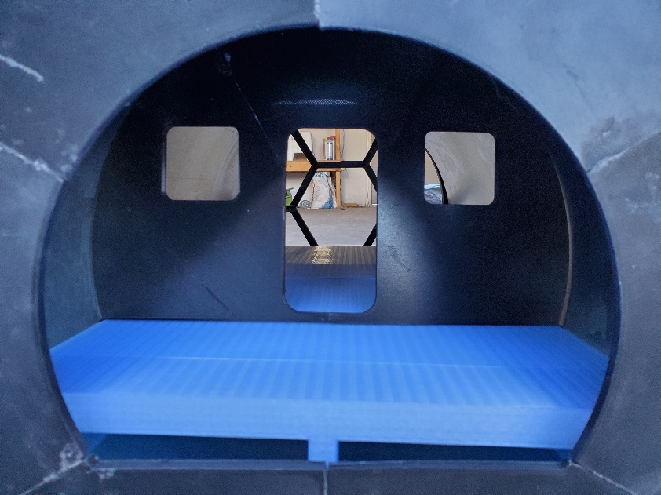
Figure 55: Interior and Exterior Air lock Doors

Subsystem 7: ECLSS
The life support systems had to be scaled down further to be able to be finished in time. These were also 3D printed with PLA and a 15% infill. A shelf was designed to be inserted under the floor that would hold all the life support systems on top of it. Figure 56 and 57 below shows the finished life support systems.

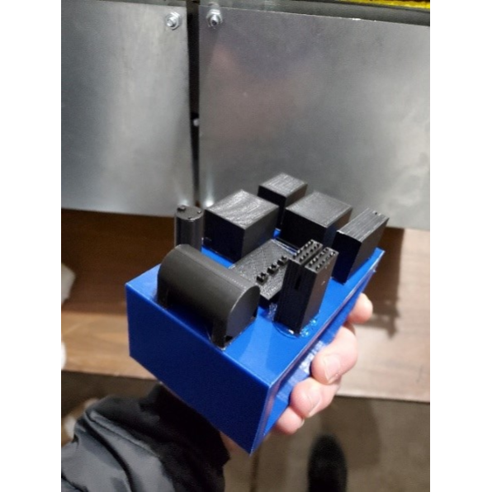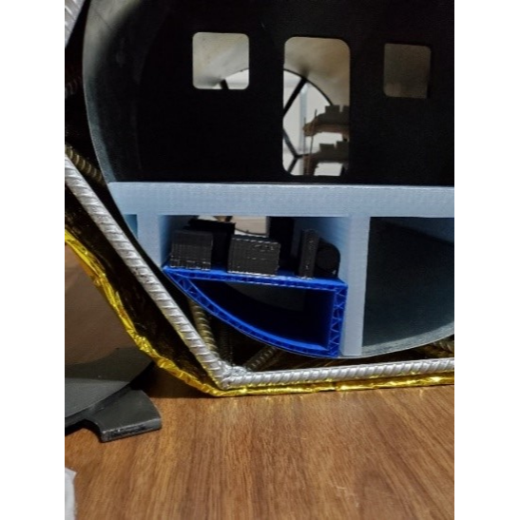

Figure 56: Installed Life Support Systems Figure 57: Life Support Systems

RISK ANALYSIS AND MITIGATION (Aidan and Jelani)
A risk analysis was done to determine the potential failures that could occur within the subsystems in the habitat. Risk mitigation was also considered to determine which failure modes could most easily be prevented.

Potential Failures Identified First Semester

ECLSS
The FMEA for the ECLSS proves that the existing design for the life systems are a prominent solution to one of the most essential aspects of the design. The ECLSS has been on board the ISS for over 15 years and has served as a forefront of the space travel revolution. Although, the system is not perfect by any means, multiple groups have researched failures of the life support system and have provided multiple approaches to the solutions.
The ECLSS subsystem is an important component of the lunar habitat because it is responsible for handling all the waste and refinement processes produced by the astronauts. It is comprised of several components. It is imperative that this system works and that all the potential failures are addressed and solved before launch to ensure that the mission is successful.
As seen in Figure 58, you can see that the largest potential failures come from the water process assembly and the atmosphere control components, particularly the particulate filter, multi-filtration bed, valve, heater, and duct failure respectively.

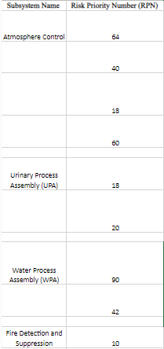
Figure 58: Shortened ECLSS FMEA

Whipple Shield
The Whipple Shield represents our habitat’s exterior protection which is designed to stop micrometeorites from penetrating and causing damage to our habitat and its inhabitants. It is comprised of four layers (Front Bumper, three Intermediate Bumpers, and a Rear Bumper) of the following materials: Aluminum 6061-T6 and Kevlar. It is held together using M-24 bolts which are also made out of Aluminum 6061-T6. For both the front and rear bumper our largest concern is that we don’t design those layers to be thick enough to be able to fully disperse all the kinetic energy created by the micrometeorite impact. For the intermediate layers our largest concern is not placing enough layers of Kevlar to stop the debris after the initial impact with the first layer. Our last concern is with the M-24 bolts and the reason for this is we are not sure how well this part will do in the environment of the lunar surface. We are afraid that if we do not choose a good material the bolts will not be able to withstand the thermal stress and strain caused by the varying temperatures. Our largest concern in terms of the risk priority number goes in the following order: Rear bumper, M-24 bolts, Intermediate bumper, and Front bumper as you can see in Figure 59.

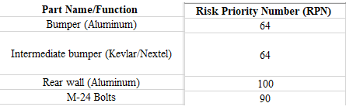
Figure 59: Shortened Whipple Shield FMEA

Potential Failures Identified This Semester
As the team progressed throughout the semester, certain notes were made about the design that could be modified in order to meet our customer and engineering requirements and keep the astronauts safe. These modifications came using the analysis done on certain components, when the team was designing the prototype, and designing the CAD model.

Whipple shield
The whipple shield has a primary focus of the exterior design that would keep the astronauts and habitat safe from micrometeorites. The repeated impact of these meteorites upon the whipple shield could puncture through not only the shields but also the habitat itself which would be lethal.

Glass Window
Another risk the team identified this semester was the incorporation of a window at the end and front of the habitat. The window was deemed necessary through the understanding of basic human requirements. The impact of micrometeorites upon the window design can be risky due to the breach through the glass window.

Solar Panels
The team has incorporated the use of solar panels for electricity generation out on the lunar surface. The risks that follow through with such a design are major if the astronauts only rely on this one source of electricity.

Heat Generation
Within the habitat, there will be many moving parts and machinery sustaining the life. Thus, there will be a ton of heat generation throughout the habitat and although the ECLSS is designed to mitigate the climate, the amount of heat created from all these systems may be higher than what the climate control system can handle.

Risk Mitigation
[Discuss how your team took the list of potential failures and designed their system to mitigate these failures. Provide design evidence that the major critical failures have a low likelihood of occurring. Also provide discussion regarding any trade-offs in risk mitigation that occurred (i.e. were any risks harder to mitigate when trying to mitigate another? Were any new risks created during the design process?).]

Whipple Shield
The team has constructed multiple analysis on the whipple shield in order to ensure the designs capabilities of sustaining through the micrometeorite collisions. As provided in section 8.8, the shield is constructed of Aluminum 6061-T6 and Kevlar and the test proved that with 5000 N of force being impacted upon the shield across the surface, the design will sustain.

Glass Window
As of right now we are using fused silica and borosilicate glass panes for the window which is space grade and will sustain through the expected size of the micrometeorites. The space grade windows will also surpass the necessary standards for internal air pressure.

Solar Panel
The solar panels have been placed in a strategic area that has been tested to be out of the common area where the micrometeorites will collide. The solar panels will not be the only source of energy for the astronauts either. The ECLSS has an incorporated energy generation system that is very reliable. The solar panels are an addition that the team decided will be a harmless back up.

M-24 Hex Bolts Fatigue Failure
Our entire micrometeorite shield will be held together with M-24 hex head bolts to ensure that our shield is secure and can accomplish the task we designed it to do. However, it can fail due to the variation in temperature on the lunar surface which can make the steel hex bolts reach plastic deformation faster. To mitigate this we will using space grade bolts. These bolts will be very similar to the ones that are used on the ISS which should be able to withstand the atmosphere on the moon.

Material Strain Failure

Strain is an important mechanical characteristic that if not accounted for could cause our design to fail. If we did not choose materials that could not survive aerospace applications our shield would succumb to the tensile and compressive stresses and forces. For example, if we chose a different type of aluminum than aluminum 7050 the temperature variation could cause our material to strain beyond repair (i.e., plastic deformation or fracture). To mitigate against this, we have chosen specific dimensions that allows our material to expand without damaging itself or other components. We have also chosen materials with a low thermal expansion coefficient as well as materials with a high tensile and compressive strength.

Composite Material Woven Failure
For the composite materials we have chosen Kevlar and Nextal because of their tensile strength as well as their thermal coefficient expansion values. However, despite the materials having strong attributes in terms of aerospace applications they can still fail due to weak weaving of the material. To mitigate failure due to weak weaving we are going to ensure that our Kevlar and Nextel is weaved in fully extended chains to create a rigid like structure.

Heat Rejection
With the ECLSS and all the other internal components, the team has focused a lot of effort into the heat rejection system that will target the areas of most heat generation and flow the air out into space, the detailed plan is in section 8.4.

ER Proofs
Table 1 below shows the teams engineering requirements and what the testing results yielded. Further detail will be shown in the report below. Testing results highlighted in green show the value has met the goal, and those highlighted in red show that the testing result has not met the goal.

Table 1: Requirements and Testing Results
Engineering Requirements | Units | Target Value | Testing Results
Budget | $/yr | 1 Billion | 4,181,263,718.56
# Of Livable Days | # | 30 | >30
Radiation Reduction | % | 60 | 84.4
Heat Rejection | kW | 30 | 33.5
Livable Space | $$m^{3}$$ | 50 | 43.5
Dry Mass Limit | kg | 6000 | 8500
Whipple Shield Impact Absorption | J | 259.2 | 7 x 10⁻⁷
Inside Air Pressure | kPa | 101.325 | Pass @ FOS:31.4

The following report details the individual engineering requirements and what testing was conducted to prove that the criteria have been met.

ER Proof #1 – Budget
Our budget for this project consists of 1 billion dollars per year up until the year of 2028. We have split our funds to be allocated to four major areas: Materials & Manufacturing, Quality Assurance & Testing, Labor Force, and Insurance. We felt that 40%, 9%, and 10% would go to Quality Assurance & Testing, Labor Force, and Insurance respectively because it is difficult to say exactly how much we would be spending on these categories since our project is very analytical. Unfortunately, our total cost per year is (4,181,263,718.56) which is way over budget in terms of how much our habitat would cost to manufacture and assemble for launch per year. This is mainly due to our part count and the materials we chose (i.e., Carbon Fiber and Aluminum 6061-T6). If we were to continue this project our goal would be to reduce the overall size (and possibly redesign the entire habitat) with the hope that it would reduce the Materials & Manufacturing cost. It is also worth noting that the Quality Assurance & Testing, Labor Force, and Insurance would vary greatly due to unforeseen circumstances that can arise during the testing and quality assurance phases.
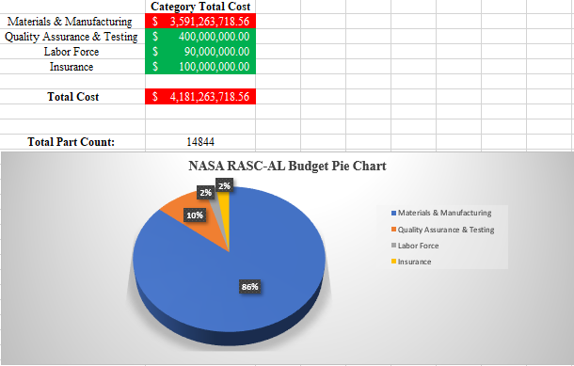
Figure 60: Budget

ER Proof #2 – Number of Livable Days
Based on the design that we have created, when considering the Whipple shield protecting the habitat, all the security measurements of assessing and deescalating tragedies on board and the oxygen and water refinery systems, the number of livable days on board the Lunar Habitat far surpasses the value of 30 days. The Whipple shield has simple design that will protect the astronauts from numerous asteroids colliding. The design will also integrate a simple way of switching out the shields that have been punctured to bring the design back to 100%.

The ECLSS has an integration from the ISS which has astronauts living in it year-round. The design of the water refinery system has an efficiency of 97% which would allow the humans to survive through only one shipment of water for up to 4 months if the efficiency began to degrade. The oxygen refinery system on the ECLSS has yet to fail NASA, therefore allowing us to assume that we will not have an issue with the oxygen system degrading. The target of a habitat sustainable for 30 days for 2 astronauts has been far surpassed in every department throughout the designs on board.

ER Proof #3 – Radiation Reduction
An analytical approach was taken to confirm the amount of radiation reduction would occur with the multi-layer insulation (MLI) shield present. The Stephan-Boltzmann law was used to determine the temperature of the outside of the habitat due to the radiation flux from the sun. This is shown in equation 1 below.
$T_{1}= {\left(\frac{Φ}{σ}\right)}^{1/4}$ (1)

Where Φ is the radiation flux from the sun, approximately 1422 W/$m^{2}K$ and σ is the Boltzmann constant. $T_{1}$ was determined to be 125°C. Equation 13.28 from Fundamentals of Heat and Mass Transfer 8th Edition [1], will be used to determine how much electromagnetic radiation energy the astronauts would see inside the habitat, and determine how much the MLI shield reduces the flux by. Equation 13.28 is shown below.
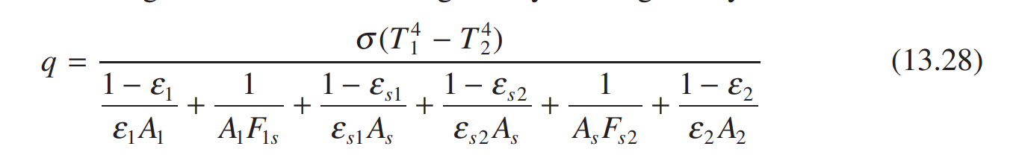
This was adopted to the nomenclature shown in figure 2 below. Figure 2 is a picture of the MLI shield and thermal radiosity network that represents the picture.
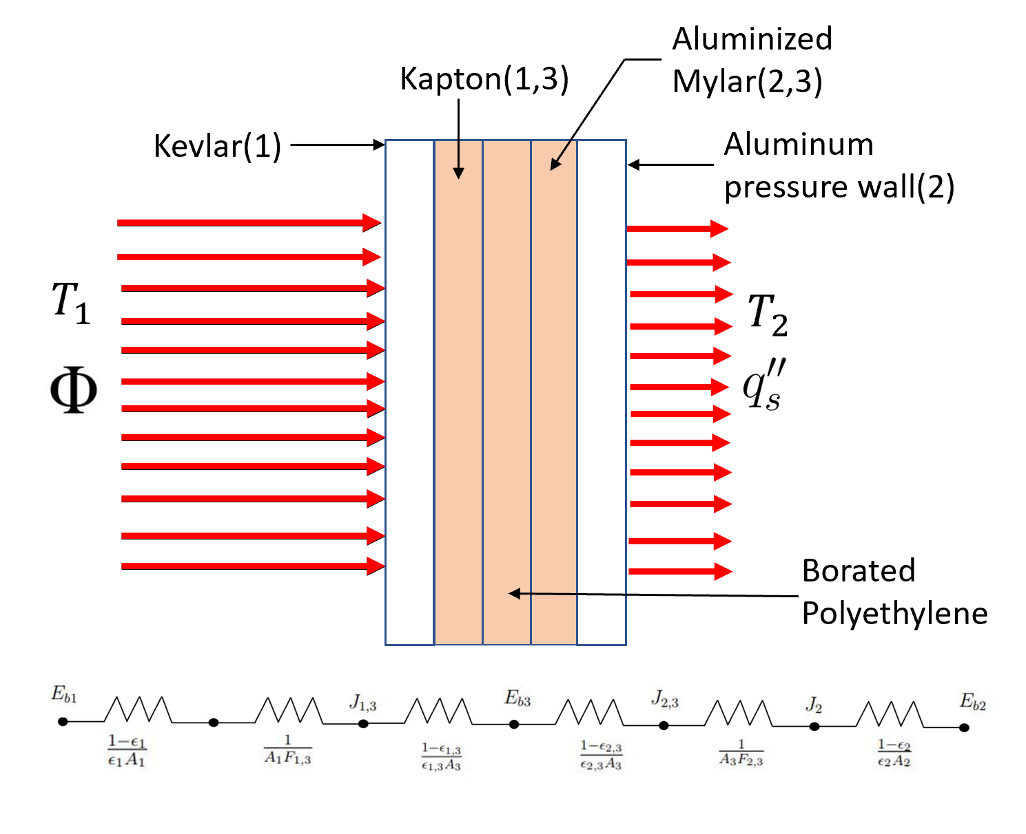
Figure 61: Multi-Layer Insulation (MLI) Diagram and Thermal Radiosity Network

Several assumptions were made to simplify equation 13.28 into the equations shown below. These assumptions are as follows:
- $A_{1}= A_{2}= A_{3}=A$
- $F_{1,2}= F_{2,3}=1$
- Surfaces are Diffuse and Gray
- Uniform Incoming Radiation Flux
- Steady State
The radiation flux with and without the shield was calculated using the process shown below. The “s” subscript represents the radiation flux with the shield. Equations 2 and 3 were adopted from equation 13.28.
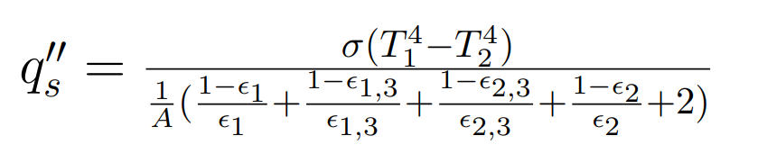
(2)
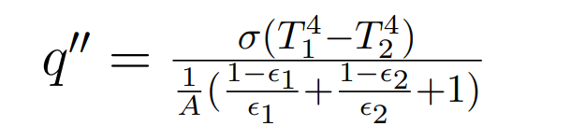
(3)
It was determined that the astronauts would see approximately 15.4 $W/m^{2}$ of radiation flux which is an 84.4% reduction from the flux calculated without the shield. This fulfilled our radiation reduction engineering requirement benchmarked from the ISS which was about 60% [2].

ER Proof #4 – Heat Rejection
The life support systems necessary to the survival of the astronauts put off an excessive amount of heat within the habitat that will not leave due to the MLI shield which also keeps heat in. For this reason, it is necessary to adapt a climate control system that can pull heat directly from the life support systems and eject it into space via radiation. The International Space Station uses a similar method, which was used as inspiration for this design. Figure 2 below shows a diagram created to better understand the ATCS (Active Thermal Control System) proposed.
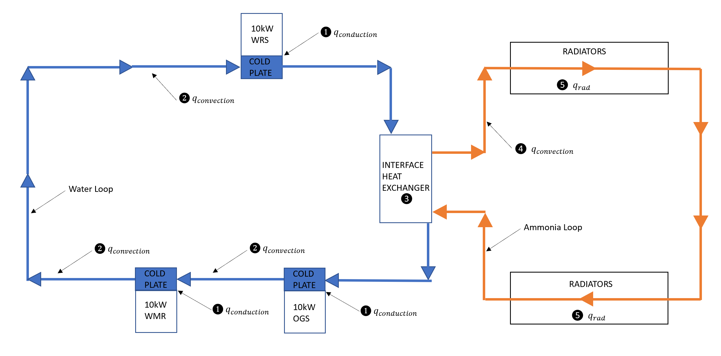
Figure 62: Active Thermal Control System

Equation 4 was derived from the first law of thermodynamics to determine the amount of heat that could be exchanged through the heat exchanger. Equation 5 was adopted to determine the number of radiators required to radiate off all of the heat exchanged from the interface heat exchanger.
$\dot{Q}= {\dot{m}}_{12}C_{p}(T_{2}-T_{1})$ (4)

$q_{rad}= A_{rad}nεσ(T_{rad}^{4}-T_{space}^{4}$) (5)

These equations resulted in a heat exchange rate of 33.5kW and 16 4m x 1m radiators necessary to radiate all the heat. This clearly meets the requirement of 30kW which was determined from downscaling heat generation values from the ISS [3].

ER Proof #5 – Livable Space
Due to healthy psychological human factors, the livable space inside the habitat needed to meet approximately 50m³. The initial habitat was built for 61.26m³ however after accounting for the floorboard, support systems and the airlock area, the habitable area came out to 42.41m³. The figure below describes the cross section of the final habitat.
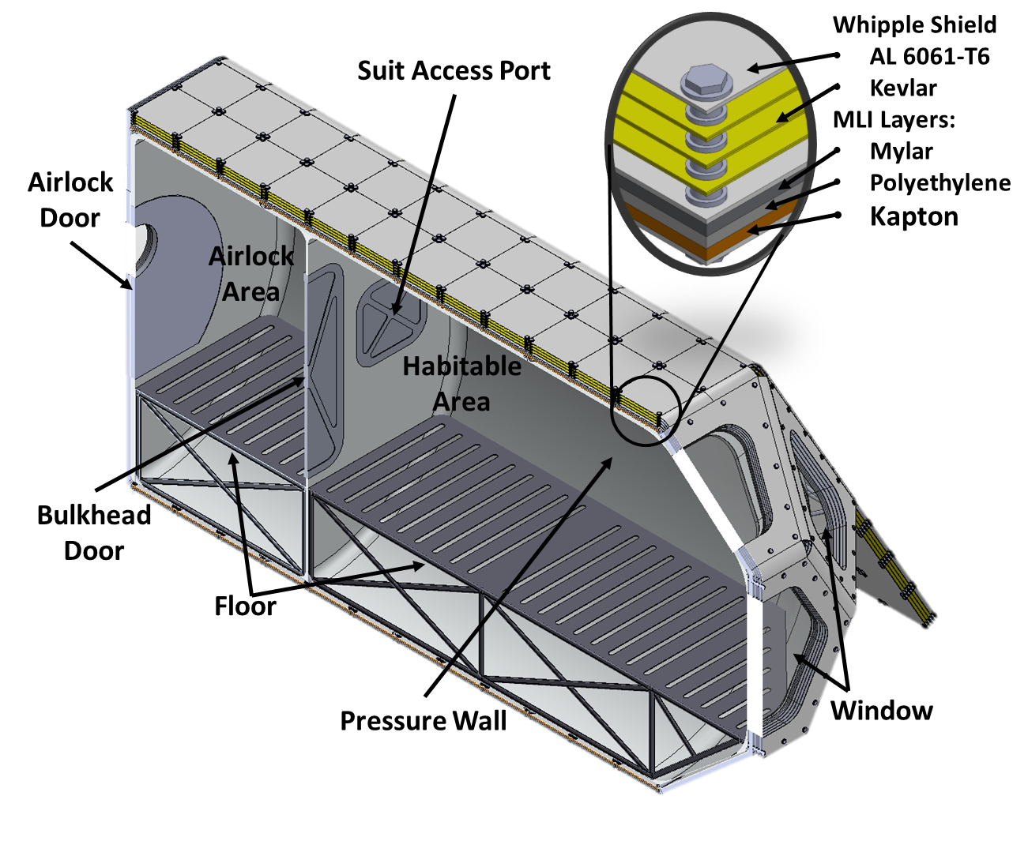
Figure 63: Final Cross Section of the Lunar Habitat

More analysis is needed to increase the habitable area back to 50m3 potentially taking the space from the space under floorboard and reducing the airlock area.

ER Proof #6 – Mass Requirement
The current dry mass including just the Whipple Shield, Multi-Layer Insulation, Bone Structure, and pressure wall comes out to 8500kg. This is 2500kg higher than the requirement of 6000Kg. However, we believe this is essential for successful Artemis lunar mission. Further analysis could be done to replace some of the materials to carbon fiber however, a thermal analysis should be conducted while accounting for internal and external pressures.

ER Proof #7 – Whipple Shield Energy Reduction
Our Whipple Shield is a simple design that is benchmarked off the I.S.S to protect our habitat from micrometeorites. To analytically simulate the energy reduction and meet our requirement of absorbing less than 259 (J) of energy a model was created within MATLAB using equations (6,7,8). Equation (6) aids in finding the amount of time it takes for a micrometeorite to travel through the any layer of the Whipple shield. Following that we have equation (7) which solves for the final velocity of the micrometeorite after the impact by assuming that the impact will be inelastic due to energy loss. Lastly, we have the basic kinetic energy equation (8) which solves the amount of kinetic energy based on the final velocity of the micrometeorite after the impact. As you can see this process was repeated for both the front and rear bumper and if you refer to the change in magnitude of kinetic energy between the front (Figure 64.) and rear bumper (Figure 65.) you can see that the energy absorbed is well below 259 (J).

$\int_{t_{i}}^{t_{f}}{v dt}=\int_{x_{i}}^{x_{f}}{dx}$ (6)
$v_{f}=\frac{m_{1}v_{1_{i}}+m_{2}v_{2_{i}}}{m_{1}+m_{2}}$ (7)
$K.E. = \frac{1}{2}m{v_{f}}^{2}$ (8)

Figure 64: Front Bumper Energy Absorption Range
Figure 65: Rear Bumper Energy Absorption Range

ER Proof #8 – Whipple Shield Energy Reduction

The Whipple test was performed using a 5mm X 5mm x 2.5mm projectile. This size was chosen as a smaller size projectile would not mesh. The test was conducted for 5000N across the surface of the projectile. The Whipple shield handled the test well which was backed up by the analytical analysis above. A new test fixture was generated using the specific materials that composed of the Whipple shield including Kevlar 49 material properties for the middle plates. All other materials including the washers were modeled with 6061-T6 Aluminum. The figure below shows the mesh model of the Whipple shield.
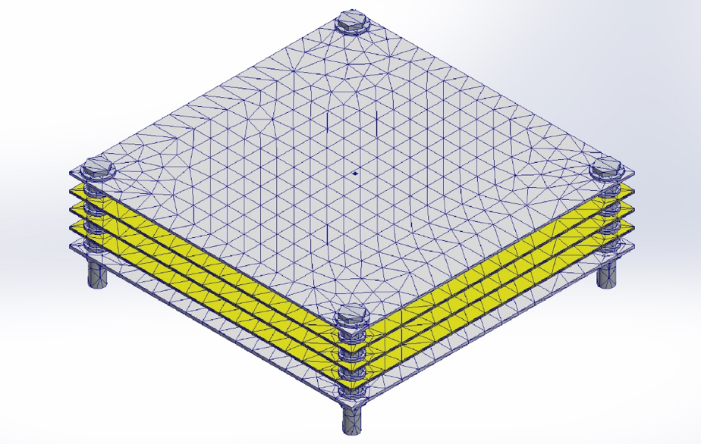
Figure 66: Whipple Shield Mesh

Further refinement was done to obtain fine mesh around the projectile and coarse for the plates to simplify the study.
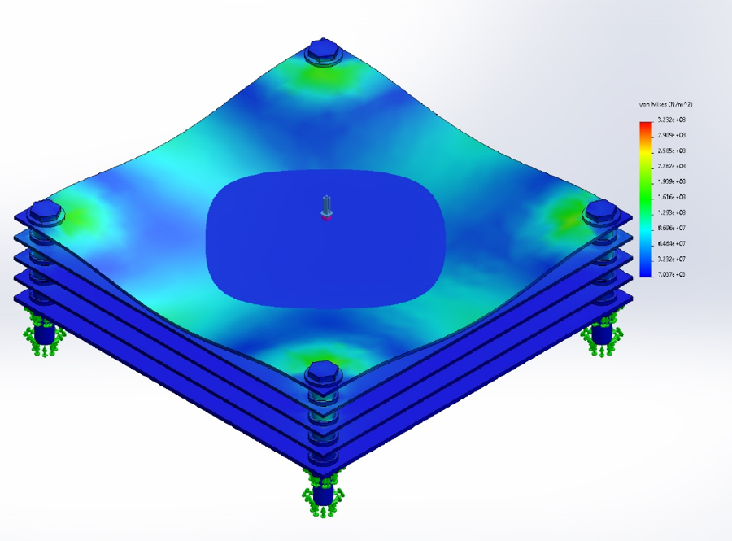

Figure 67: Von Mises Stress Results
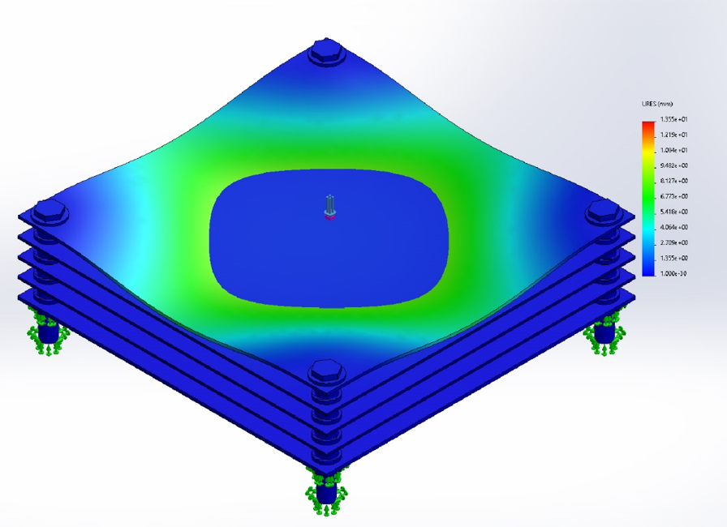
Figure 68: Displacement Results
Figure 69: Total Displacement Result

The results are from the study showed that the maximum deformation is 3.691mm, maximum stress of 323.2MPa and maximum displacement of 13.5mm which is acceptable for the force tested for. This is in line with the analytical analysis and does predicts that the energy absorption is indeed a success. Thus, based on the results, the test was a pass. However, a non-linear simulation with a smaller projectile might be necessary to closely model the impact at an angle.

ER Proof #9 – Internal Air Pressure
Two studies were conducted for the pressure wall analysis. Initially, a simulation was run assuming that the pressure wall thickness is at 25.4mm for 6061 T6 Aluminum. The results of the study are provided below.
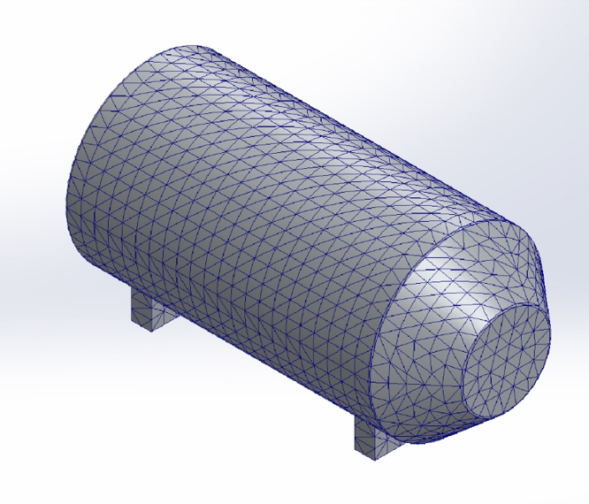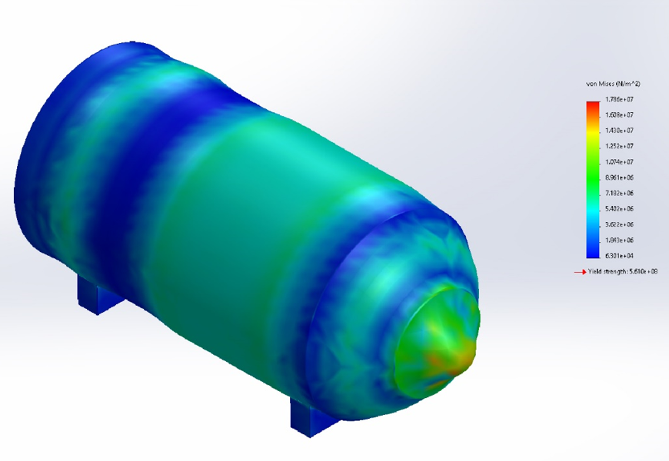
Figure 70: Mesh generation and Von Mises Stress Results

As shown above, support structures were added to the model and the test was conducted for atmospheric pressure of 101,300Pa. The study resulted in a Max Stress at Nose of 17.86MPa, max displacement of 2.17mm and a factor of safety of 31.4. The maximum stress is at the nose will be addressed as the nose will be replaced with window that will be able to handle the extreme pressure concentrations.
Once the thickness of the pressure was determined to be accurate, analytical calculations were performed to account for the desired weld quality. The formula used for the analysis is provided below.
$t=\frac{P*D}{2((S*E*W)+(P*Y))}$ (9)

Where,
T = Wall Thickness
P = Maximum Internal Pressure
D = Outer Diameter
S = Allowable Stress
E = Weld Quality Factor (Fusion Welded Pipe)
W = Weld Joint Strength
Reduction Factor (0.5)
Y = Wall Thickness Coefficient

The following describes the analysis steps.
- Determine Max Pressure of the cylinder.
P = 101300 Pa
- Determine allowable stress of the wall material. Sy = 241Mpa (35ksi)
- Solve for the pipe thickness using the ASME code B31.3 Standard for Internal Piping Stress.
- Verify the thickness is validated through the Simulation conducted earlier.
- Result, t = 0.00269m, increase from 0.00254m
As described above, the thickness of the wall was increased from 0.00254m to 0.00269m to account for the weld quality (increase of 5.9%).

LOOKING FORWARD
The finished CAD model depicts all crucial subsystems required by the engineering requirements. However, the analytical analysis could be further improved by conducting physical tests for the simulations. The testing procedures described below will be validated by the computational analysis and analytical calculations described in the previous section. In addition, future work that needs to be done for a successful completion of the lunar habitat is also detailed in this section.

Future Testing Procedures
The following section details two physical testing procedures that would help improve confidence in the design model.

Testing Procedure 1: Bone Structure Weld Quality

Testing Procedure 1: Objective
The bone structure piping will be held together using tig welds as 6061 T6 Aluminum is the chosen material. It would be essential to determine the integrity of the structure as the temperatures on the surface of the moon could reach 150˚C.
As a result, the objective of this test would be to determine the structural integrity of the weld by conducting a stress test at extreme temperatures.

Testing Procedure 1: Resources Required
[Provide a complete description of necessary items for the test to be completed satisfactorily. This includes (but is not limited to): people, software, hardware, tools, location, etc.]
The resources required are listed as follows:
- Sample 6061 T6 Aluminum Welded Tubing
Since the weld quality is the topic of examination, the test sample does not need to utilize a full-scale model. However, it is important to manufacture Tig Welded 6061 T6 Aluminum.

- Thermocouples attached to the tubing for temperature monitoring.
The thermocouples will be attached to the sample at the point of interest to measure and monitor the temperature.

- ATS Series 3310/3320 High Temperature Tube Furnace.
The device illustrated in figure 71 below illustrates two high temperature tube furnaces capable of handling up to 1800˚C. The furnace has a tube chamber that is open on both ends to allow the tensile test stand to hold the sample within the furnace.
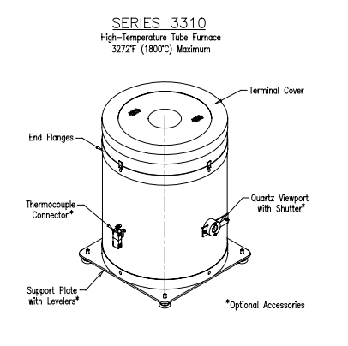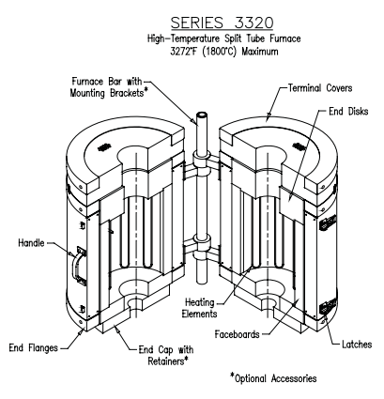
Figure 71: High Temperature Furnace [37]
- Epsilon Model 3549 Hot Mountable Furnace Extensometer for strain measurements.
The Extensometer uses two ceramic rods to measure the strain changes as the sample is tested. The epsilon model 3549 extensometer can handle high temperatures of up to 1600˚C and is sensitive to minor vibrations. The device is rated with ASTM E606 Standards. The figure below illustrates the device with
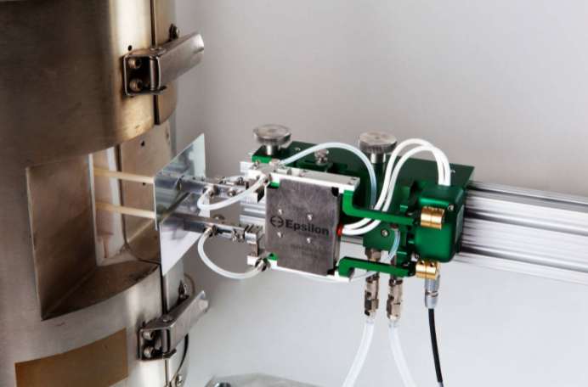
Figure 72: Epsilon Model 3549 Extensometer [38]

- Fixture Rods
The fixture rods hold the sample in place and will need to withstand the desired temperatures faced inside the furnace.

- cDAQ Ni-9213 thermocouple module
This device will be used to measure the voltage output received from the thermocouple. The TC cables positive wire is color coded by yellow and negative wire by red. Although the cDAQ NI-9213 contains 16 channels, only one channel will be used. The eDAQ module converts the microvolt analog TC Signals to Volts with 2²⁴ bits of precision which is read by the LabView software which uses clock data from the computer to determine the frequency of data read.

- National Instrument LabView software
This software will be used to read the thermocouple voltage and write it to a file. Calibration will be required to convert the voltage to temperature.

- Mark-10 ESM303 Advanced Motorized Test Stand for tensile testing.
The test stand below is rated for a tensile force of 600lbs. Although the test stand offers peel testing and spring testing, we will focus on the tensile testing. The stand is motorized and can be controlled using a computer software as well as physical force gauge mounted to the stand.
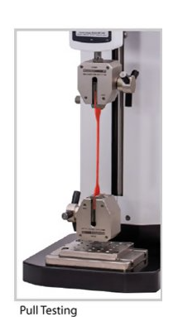
Figure 73: Mark 10 ESM303 Tensile Test Stand [39]

Testing Procedure and Schedule
The test should take approximately three hours from start to completion for each set of data collection after obtaining all the required resources. The test assumes that the entire sample achieves steady state and as such is heated for an additional 30 minutes after the desired temperature is reached. In this case, it will be 150˚C and 200˚C.
The test setup involves the following steps.
- Prepare the sample for testing. This involves checking the diameter of the sample tubing.
- Install the thermocouple on to the sample 6061-T6 Aluminum tubing.
- Attach the sample to the fixture rods.
- Place the fixture rods on to the Mark 10 Tensile Test stand.
- Wrap the furnace on to the test stand to enclose the sample at the center of the furnace.
- Ensure the thermocouple connection is secure while feeding it out of the furnace.
- Attach the Epsilon Extensometer on to the sample tubing while adjusting the height of the device.
- Then start the LabView software to start collecting the temperature data.

Once the experimental setup is complete, the test will be conducted by starting the furnace to start heating the sample plate. Once the sample achieves the desired temperature, the furnace heating will be controlled to maintain the temperature for 30 minutes to ensure steady state and that the entire sample achieves constant temperature. This will be followed by increasing the tension on the sample while recording the strain measured by the Extensometer. The tension will be increased till the sample yields. When this happens, the extensometer will be removed from the sample to avoid damage. Then the tension will be increased till the sample buckles and ultimately shears.
Conducting this test will provide confidence in the Bone Structure tube thickness and may result in decreasing the thickness to reduce wight.

Testing Procedure 2: Whipple Shield Non linear Impact Testing

Testing Procedure 2: Objective
The HITA (High Impact Test Analysis) test will be conducted analytically by using the computer-aided design software Solidworks. This is for the purpose of discovering whether our design can withstand the high levels of kinetic energy that a high-speed micrometeorite can create. We are also attempting to understand how much damage other physical parameters will have upon impact with our shield (i.e., Oblique impact versus Normal impact, Pressure, Impulse, Momentum, etc.). The information that we gather will allow us to make the proper adjustments to ensure with confidence that our astronauts will be safe for the duration of this project (thus satisfying our number of livable days engineering requirement and safety which is a customer requirement). With the inclusion of the final materials selected this will help to prove the viability of the current Whipple Shield design by creating a 500mm-by-500mm section for impact analysis.

Testing Procedure 2: Resources Required
For our tests to run smoothly we will need the full suite of Solidworks as well as the linear and non-linear dynamics packages. To access this software and the necessary add-ons the students will need to use the engineering building’s computers or personal computers with the full version and necessary addons. The team may also benefit from the assistance of one impact specialist and a Solidworks professional. The only resource necessary for the analysis is a high performance computer equipped with the full scale Solidworks software.

Testing Procedure 2: Schedule
Testing could take anywhere between one week to over two weeks depending on how long it takes me to understand the software packages. The team will need to have a better understanding of CAD packages and impact analysis over the coming weeks. Before any of the testing can happen, the students will need to ensure my thought process about the physical concepts surrounding the micrometeorite shield is correct by doing some back of the envelope calculations. To assist by providing a visual representation of the calculations, the students will be using MATLAB to create various plots of different physical parameters.

Future Work
Moving forward, more work can be done to improve the existing proposed design. One crucial component that requires work is full system weight reduction. This would be to try to get the habitat to meet the dry mass limit engineering requirement. A detailed manufacturing plan and schedule could be created to better understand how to implement the habitat. Finally, the power system for the habitat could be designed.

Weight Reduction
The pressure wall analysis was conducted for 6061-T6 Aluminum. However, carbon fiber is an alternative that the team initially disregarded as a change in temperature would compromise its structural integrity. However, once confidence of safety from micrometeorites is obtained, it would be safe to assume that the internal temperature would be maintained. Making carbon fiber a good alternative followed by potential analysis.
Although the bone structure weighs about 172.9kg making it the lightest components, weight reduction at a very possible avenue should be taken advantage of. The bone structure is also enclosed completely by the MLI and further analysis for material selection for weight reduction could also be possible.
Additional weight reduction opportunities could be with the internal floorboard, air lock, and Whipple shield. Material analysis should be conducted for each of these components to further reduce weight.

Manufacturing Plan
Future work could be done to devise a manufacturing plan to build the full-scale habitat. Information on vendors for parts and raw materials would need to be gathered to be able to make a thorough manufacturing plan. Each subsystem could get broken down into chapters for how construction process, along with all of the manufacturing processes required to build the subsystems. Although a budget was proposed for this project, it is more than likely there are unforeseen manufacturing accidents that could cause for additional expenses, so a more in depth look into the manufacturing budget will be necessary for a proper cost estimation.
The next step for the manufacturing plan is to create an accurate manufacturing timeline. With COVID-19 causing supply chain issues, there is no doubt that there will be parts or materials on backorder. For this reason, it is important to create the manufacturing timeline as early as possible. On top of parts and materials, it is important to have the proper facilities and equipment to manufacture the final product. Given that this is for a government project, this should be no issue.
Finally, a plan for maintenance and quality assurance can be devised by the engineers overseeing the manufacturing process. Designing the habitat to be able to be maintained is important for potential failures that could occur on the surface of the moon.

Power System
To power the various life support systems, experiments, and to store electricity for the longevity of our habitat and its inhabitants we will be using solar panels modeled similarly to the ones used on the I.S.S as shown in Figure 74.. Depending on where we would place our habitat within the south pole would determine how large and the geometry of the solar panels but ideally, we would want our panels to be about 12.5% of the size of the I.S.S’s solar panels. Which means that each of the four solar panels will 14 ft x 5 ft which will produce approximately 13 (kW) of power.
We would also structure the electrical layout of the panels the same way (meaning through a direct current) because the distance between the panels and the battery would not be great enough to implement an alternate current (AC) model. To store the electricity that isn’t being used for the life support systems we will be using a lithium-ion battery. It is important to note that not all of the electricity capture will be used for the functionality of the habitat, a majority of the power will be stored within the battery. This will act as a fail-safe just in case an electrical component breaks and needs maintenance the habitat will still be able to function. It will also be helpful if we happen to place the habitat in a location that is only partially exposed to the sun.

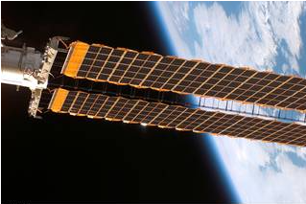
Figure 74: I.S.S Solar Panels

CONCLUSIONS
The lunar habitat design project challenged the team with designing a low-mass durable lunar habitat for use at the lunar south pole. The team had to design the module to be habitable for 30 days on the lunar south pole. The team set a goal of putting astronaut safety as a priority before all else and focusing on the subsystems that would keep the astronauts alive. These subsystems included: bone structure, pressure wall, micrometeorite protection, radiation mitigation, life support systems, and air lock assembly. A lot of effort went into the construction of a scaled prototype this semester to better understand the manufacturing procedures required to construct the proposed design. This guided the team to make design changes to make the manufacturing process easier for a full-scale prototype. A lot of thought went into computational analyses and theoretical calculations to validate the team’s final design and make changes and improvements. The iteration and testing resulted in a much more thorough design than initially proposed in the first semester. The team was able to meet almost all of the engineering requirements, however further improvements can be made to the future design; specifically, to cut weight down to meet the mass requirement.

Reflection
The most important factor for this project was user safety. The lunar habitat design proposed by the team prioritized the safety of the astronauts above all else. The safety of the design was validated through engineering calculations and simulations. Most of the thought was put into the subsystems that would cost the astronauts their lives if failure occurred. Because of this, impact, pressure, and thermal simulations along with engineering calculations were used to verify the safety of the design. Although the design didn’t meet all the engineering requirements, all the requirements that were directly tied to safety were satisfied which is a significant accomplishment. Looking forward, the team would hope to use future testing procedures proposed earlier in the report to test a few more factors that could cause failure or create issues for the astronauts inside.

Post-Mortem Analysis of Capstone
A post-mortem analysis of the capstone process was done to learn from the mistakes the team made throughout the year, and to understand what contributed to the team’s success.

Contributors to Project Success
The team members were able to successfully follow through on the procedures and goals stated within the team charter to ensure that the team could efficiently progress at a steady pace. This was accomplished by dedicating necessary time towards research and performing several types of analyses (i.e., Hypervelocity Impact, Thermal Radiation, Structural Integrity, Human Factors, etc.). The result of these endeavors was a full CAD model of our final design.

The team excelled technical content, communication, scheduling and maintained a healthy outlook throughout the project. Team members excelled at various technical expertise based on engineering coursework, personal interests, and hands-on experiences. However, due to the scope of the project, everyone was required to become subject matter experts in specific areas. The members are either assigned to a section and/or selected by themselves. For example, Ryan excelled at CAD modeling and spent much of his time generating various models and helped the rest of the teammates with their tasks. Aidan focused on thermal analysis and radiation mitigation and manufacturing the prototype, Keith with structural and Whipple shield analysis, Jelani with the Whipple shield, and Salar focused on life support systems.

The team primarily used Microsoft Teams to host weekly meetings and Snapchat for daily communication. The team was able to communicate effectively and in a timely manner with one another. According to the team charter, the team was supposed to meet in person at least once a week. However, due to the COVID-19 pandemic, the team was forced to meet on teams for the entirety of the first phase including professor and capstone coordinator meetings. The team was able to meet in person and online through the remainder of the project.

The team credits this success to strictly adhering to the ground rules and coping strategies that were agreed upon in the beginning of the Spring 2021 semester. This includes but is not limited to engaging in open dialogue, weekly meetings, and team voting. One of the teams’ strongest aspects was our ability to communicate with one another, especially in times of family emergencies. The team was respectful and considerate as the team allowed an ample amount of time for members to complete their individual assignments while also recuperating from personal emergencies that arose from COVID-19.

Throughout the 2021 school year, the COVID-19 virus brought diverse types of difficulties that nobody could have imagined. With classes being taught completely online, the learning environment was different from what all the students had grown accustomed to. Essentially, having to reteach the material to oneself and with a much shorter and compressed semester, time was not on our side. The team had few opportunities to meet in person as each member had personal time constraints and often fell into sickness and did not want to risk spreading the infection. With a more compressed first semester and no breaks throughout the semester, a very widespread conflict of mental health awareness grew throughout the Northern Arizona University (NAU) community, especially the Engineering department. Luckily, the professors were very understanding and assisted the student in every feasible way, while COVID-19 had every intention of challenging the students and staff.

One of our strongest performances on the project was our ability to produce a final design in CAD (Solid works) using scientific data that was researched, collected, and analyzed by the team. For example, the hypervelocity impact shield (H.V.I.T.) that was implemented within our lunar habitat design was benchmarked off the International Space Station’s (I.S.S.) H.V.I.T. Using the information collected on the I.S.S. (which included material selection and dimension analysis) the team was able to design a shield that would meet our design requirements and customer requirements. In the second semester, the team excelled in physical prototyping and computational testing. With the design foundation set in place from the spring semester, the team was able to test, iterate, and improve upon the previous proposed design.

Opportunities/areas for improvement
Although the team did well to maintain steady progress, the team ran into a few roadblocks along the way. For example, some team members struggled with logging their hours on the timesheet. Many team members would simply put in the time they thought they worked at the end of the week on Monday. To get a more accurate representation of how many hours are spent on the project, team members will aim to log their hours directly after they get done working on the project. The team will also aim to be more specific in the notes they add on the timecards to provide a more accurate description of the work that they individually complete. This was improved upon in the second semester and allowed the team to log their time more accurately.

Another area of improvement is starting the reports early. One of the teams' strongest aspects is the various personalities they brought. However, this meant that the weakest aspects were the different mentalities when it came to time management. Although the reports were completed on time, not all team members would start their portion assignments early which forced the report completion close to the deadlines. This did not allow our team to ask clarifying questions which would have been otherwise beneficial in producing more quality work. Nonetheless, towards the end of the semester the team completed all assignments.

However, this meant a higher stress environment within the team to complete reports due to time constraints. To mitigate this, the team will have soft deadlines seven days and five days before the reports are due and a hard deadline three days before the reports are due. The soft deadlines (warning) are set for starting the reports, establishing the outline, and initiating the writing process thus identifying the problems with areas of the report. A hard deadline (completion of assigned tasks) is set three days before the report is due and entails the completion of the final draft. This means the remaining tasks for the report involve editing text and outline of the document. As a team, the team believed that these deadlines would help mitigate high stress environments close to the due dates. Throughout the semester the team followed this process up until about halfway through when the deadlines got more and more time consuming. Although the team did not adhere to this strict completion strategy, we believe that this mindset allowed the team to finish the assignments in a more complete and well-thought-out manner.

To reiterate, the team did well to meet up more than twice a week. However, there were rare incidents where teammates could not be present due to scheduling conflicts. To get the biweekly update and cater to rare absences, teammates will be encouraged to post a written update on any completed, in-work and upcoming tasks. It is essential for teammates to communicate this for a healthy team environment and for short-term and long-term planning. As a result, the communication plan calls for two weekly check-ins of half an hour on Monday and Friday (subject to change based on team member schedules). Team members will be encouraged to attend the meeting in person; to accommodate unforeseen circumstances, team members may join through Microsoft Teams as needed. To promote adherence, the meeting will be held after class on Monday and Friday. This goal was not met this semester as team members struggled to meet once a week due to being busy with jobs and other school obligations. The team was able to get a lot of communication in during weekly staff meetings with David Willy, which helped keep us on track.

REFERENCES
[1] E. Sefton-Nash, “Thermal Extremes in Permanently Shadowed Regions at the Lunar South Pole,” Lpi.usra.edu
[2] “Space Radiation”, Nasa.gov, 2021
[3] G. Heiken, “Lunar Sourcebook: a user’s guide to the Moon,” ipi.ursa.edu
[4] L U N A R K. [Online]. Available: https://lunark.space/. [Accessed: 01-Feb-2021].
[5] H. Benaroya, “Lunar habitats: A brief overview of issues and concepts,” REACH, 12-Aug-2018.
[6] R. Cairns, “NASA wants to build a lunar base by 2030. Could 3D printing with moon dust be the answer?” CNN, 18-Dec-2020.
[7] Zhao, Bing, Hu, Jianhui, Chen, Wujun, Chen, Jianwen, Qiu, Zhenyu, Zhou, Jinyu, and Gao, Chengjun. "An Automatic System for Pressure Control and Load Simulation of Inflatable Membrane Structure." Automation in Construction 90 (2018): 58-66. Web.
[8] Li, Weijie, Zeng, Fuming, Chen, Geng, Deng, Yuanbin, Liu, Guoqing, Zhang, Xiaoyu, Bezold, Alexander, and Broeckmann, Christoph. "Shakedown Analysis for Structural Design Applied to a Manned Airtight Module." The International Journal of Pressure Vessels and Piping 162 (2018): 11-18. Web.
[9] Advances in Space Science and Technology. Volume 3. United Kingdom ed. 1961. Advances in Space Science and Technology. Web.
[10] D. A. de Rooij, Space Materials Database. Materials data for space applications. [Online]. Available: https://www.spacematdb.com/. [Accessed: 01-Feb-2021].
[11] G. Chapline, "Materials and Manufacturing", Nasa.gov, 2021.
[12] A. P. Mouritz, Introduction into Aerospace Materials. Reston, VA: Woodhead Publishing, 2012.
[13] H. Benaroya, “Lunar habitats: A brief overview of issues and concepts,” REACH, 12-Aug-2018.
[14] Nasa.gov. 2021. [online] Available at: <https://www.nasa.gov/sites/default/files/atoms/files/nasa-std-3001-vol-1a-chg1.pdf> [Accessed 30 January 2021].
[15] Nasa.gov. 2021. [online] Available at: <https://www.nasa.gov/sites/default/files/atoms/files/nasa-std-3001-vol-2a.pdf> [Accessed 27 January 2021].
[16] “Lunar habitats: A brief overview of issues,” Scholarship.libraries.rutgers.edu. [Online]. [Accessed: 3-Feb-2021].
[17] D. Akin and U. of Maryland, “A parametric comparison of microgravity and microgravity habitat design elements,” International Conference on Environmental Systems (ICES)
[18] “Erau Commons - Embry–Riddle Aeronautical University.” [Online]. Available: https://commons.erau.edu/cgi/viewcontent.cgi?article=1591&context=publication. [Accessed: 3-Feb-2021].
[19] Building a lunar base with 3D printing,” ESA, 31-Jan-2013
[20] National Research Council, “Read ‘Protecting the Space Station from Meteoroids and Orbital Debris’ at NAP.edu,”
[21] N. Scharping, in What Can Stop a Speeding Bullet? A Whipple Shield, of course.
[22] National Research Council, “Read ‘Protecting the Space Station from Meteoroids and Orbital Debris’ at NAP.edu,”
[23] N. Scharping, in What Can Stop a Speeding Bullet? A Whipple Shield, Of Course,
[24] “ARES HyperVelocity Impact Technology,” NASA
[25] 3M—Nextel—Ceramic Fibers and Textiles Technical Reference Guide,” 01-Nov-2018.
[26] “The International Space Station (ISS) flight systems.”57
[27] E. Samuel, “Space station radiation shields ’disappointing’,” New Scientist, 23-Oct-2002.
[28] “Temperature on Earth and on the ISS,” Let’s Talk Science, 23-Sep-2019.
[29] “About the Spacecraft,” About the Spacecraft — National Air and Space Museum.
[30] D. R. Williams, “Apollo 11 Lunar Module / EASEP,” NASA Space Science Data Coordinated Archive.
[31] D. J. Benford, T. J. Powers , and S. H. Mosley, “Cryogenics,” Thermal conductivity of Kapton tape.]
[32] “Active Thermal Control System (ATCS) Overview.”
[33] E. Samuel, “Space station radiation shields ’disappointing’,” New Scientist, 23-Oct-2002
[34] [R. B. Malla and K. M. Brown, “Determination of temperature variation on lunar surface and subsurface for habitat analysis and design,” Acta Astronautica, 04-Nov-2014.
[35] E. Samuel, “Space station radiation shields ’disappointing’,” New Scientist, 23-Oct-2002
[36] [J. Doyle, B. Haley, B. Galyean, and D. T. Ingersoll, “Highly Available Nuclear Power for Mission-Critical Applications,” Nuclear Technology, pp. 1–16, Feb. 2020, doi: 10.1080/00295450.2019.1699382.]
[37] “Furnaces Laboratory and Industrial Precise, Effi cient, and Reliable Furnaces and Process Systems Made to Your Specifi cations.” Accessed: Dec. 04, 2021. [Online]. Available: https://www.atspa.com/furnaces_r2.pdf.
[38]“High Temperature Hot Mountable Furnace Extensometers (1200°C or 1600°C) - Model 3549,” Epsilon Tech. https://www.epsilontech.com/products/hot-mountable-furnace-extensometer-model-3549/ (accessed Dec. 04, 2021).
‌ [39]“Mark-10 ESM303 High Performance Motorized Test Stand, Tensile Tester Machine, Elongation Tester, Compression Testing,” www.abqindustrial.net. https://www.abqindustrial.net/store/mark-10-esm303-advanced-motorized-test-stand-300-lb-capacity-p-1260-op-1719_7715.html?msclkid=3d76ae4f5a8616a8bc3ecfe5c407af52 (accessed Dec. 04, 2021).
‌[40] D. S. Mckay and D. W. Ming, “Properties of lunar regolith,” Developments in Soil Science, 02-May-2008. [Online]. Available:https://www.sciencedirect.com/science/article/abs/pii/S016624810870360X. [Accessed: 04-Feb-2021].
[41] Harry W. Jones “Using the International Space Station (ISS ... - ntrs.nasa.gov.” [Online]. Available: https://ntrs.nasa.gov/api/citations/20160014553/downloads/20160014553.pdf. [Accessed: 04-Dec-2021].

[42] P. Weiss et al., “THE SHEE PROJECT SELF-DEPLOYABLE HABITAT FOR EXTREME ENVIRNOMENT TEST-BED FOR ANALOG SIMULATIONS Introduction: A space habitat simulator in Europe.” Accessed: Oct. 15, 2021. [Online]. Available: https://liquifer.com/wp-content/uploads/2020/03/2014_THE_SHEE_PROJECT_SELF_-_DEPLOYABLE_HABIT_paper.pdf.
[43]V. Disher, T. Kobrick, and R. Kring, “Human Factors for Small Net Habitable Volume: The Case for a Close-Quarter Space Habitat Analog,” 2017. [Online]. Available: https://commons.erau.edu/cgi/viewcontent.cgi?article=1591&context=publication.
‌

APPENDICES

Appendix A: FMEA (ECLSS & Whipple Shield)

ECLSS FMEA

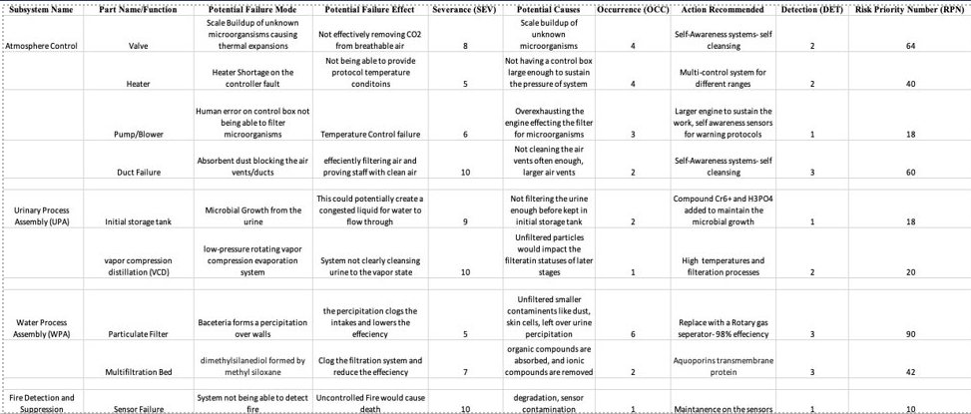

Whipple Shield FMEA
